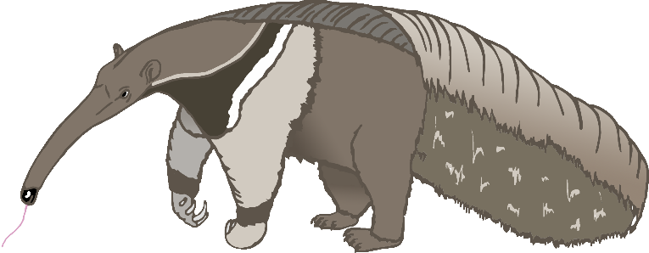

Aa

anteater

Bb

bat

Cc

cow

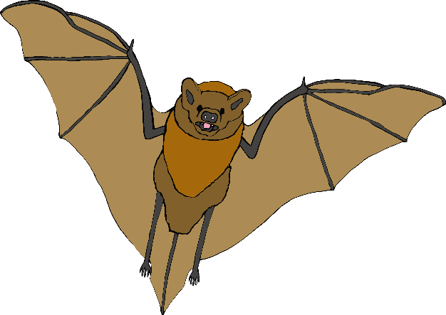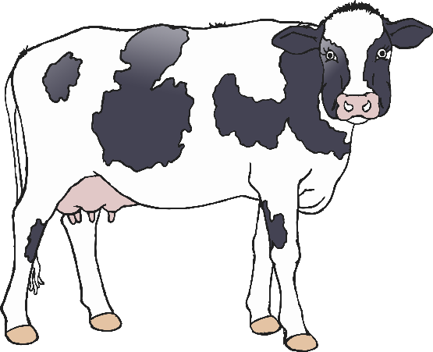

Dd

dog

Ee

elephant

Ff

frog

Gg

goat

Hh

horse

Ii

iguana

Jj

jellyfish

Kk

kangaroo

Ll

lion

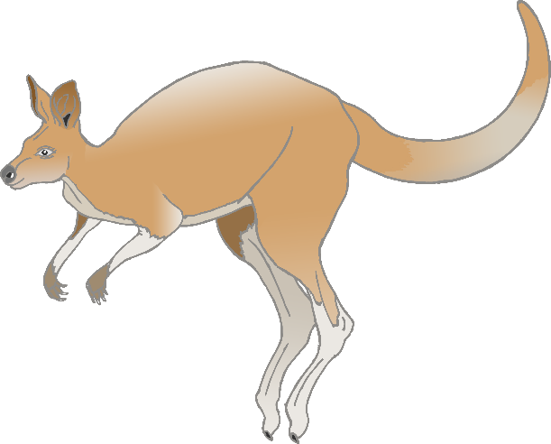

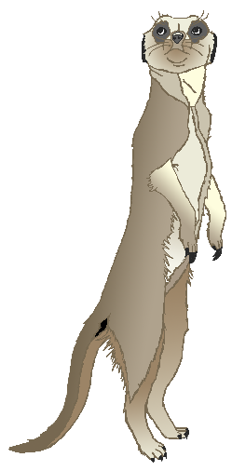

Mm

meerkat

Nn

narwhal

Oo

octopus

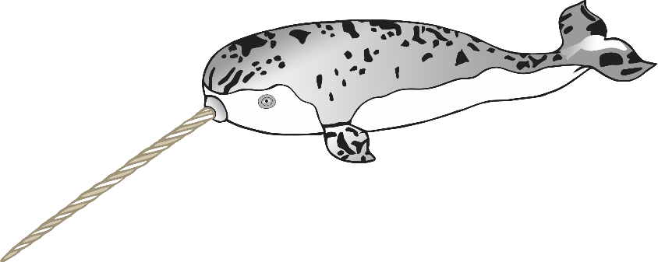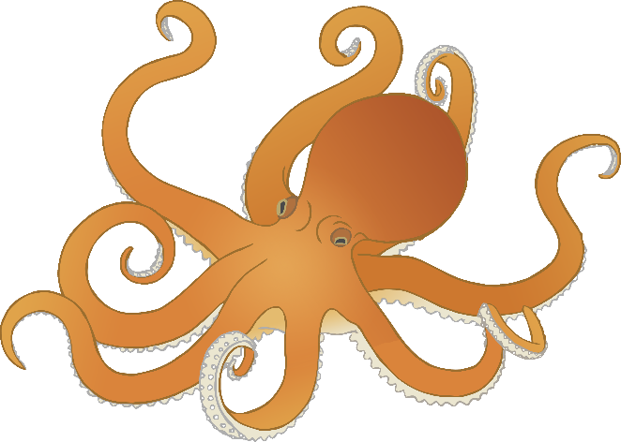

Pp

pig

**Q**q

quail

Rr

rabbit

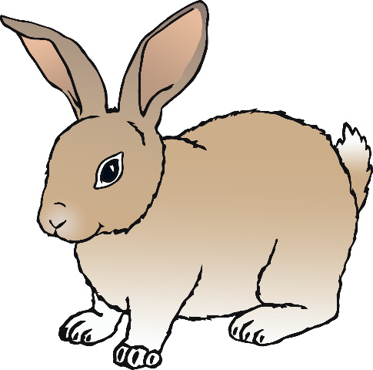

Ss

squirrel

Tt

tiger

Uu

umbrella bird

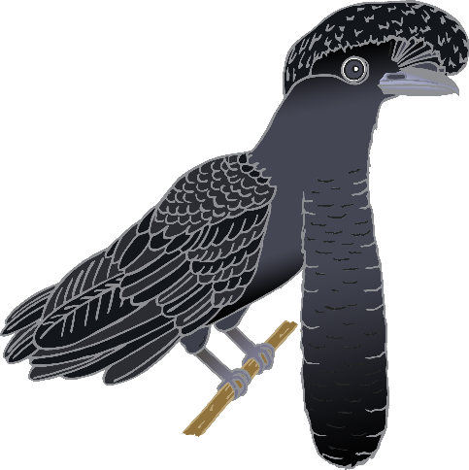

Vv

vulture

Ww

wolf

Xx

fox

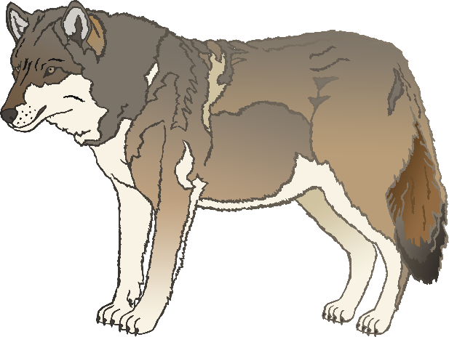

Yy

yak

Zz

zebra