**Lions Room**

Children’s names here…

© 2020 Little Owls Resources

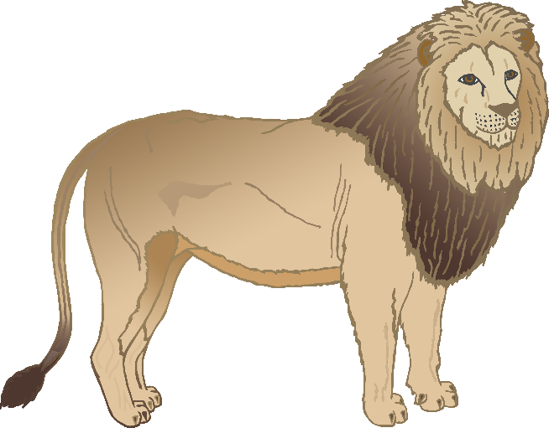

**TIGERS Room**

© 2020 Little Owls Resources

Children’s names here…

**WOLVES Room**

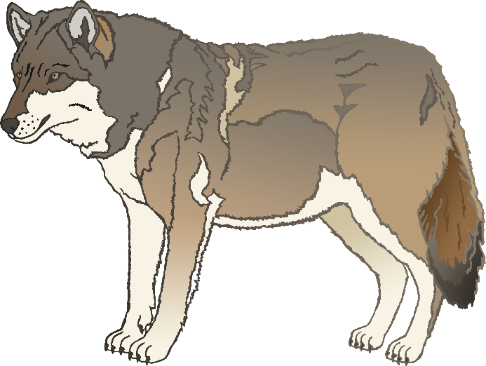

© 2020 Little Owls Resources

Children’s names here…

**Zebras Room**

© 2020 Little Owls Resources

Children’s names here…

**Giraffes Room**

Children’s names here…

© 2020 Little Owls Resources

**Rhinos Room**

Children’s names here…

© 2020 Little Owls Resources

**Lions Room**

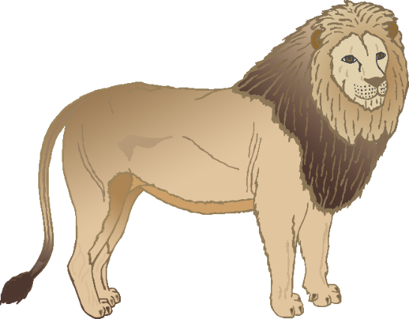

© 2020 Little Owls Resources

© 2020 Little Owls Resources

**Tigers Room**

**WOLVES Room**

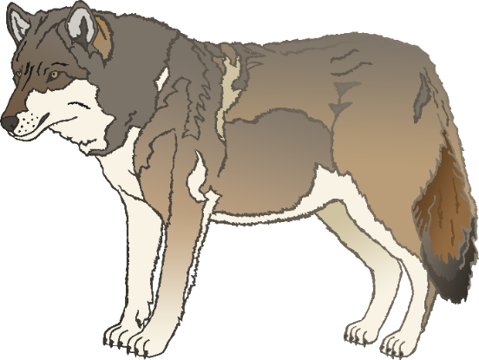

© 2020 Little Owls Resources

**Zebras Room**

© 2020 Little Owls Resources

**Giraffes Room**

© 2020 Little Owls Resources

© 2020 Little Owls Resources

**Rhinos Room**

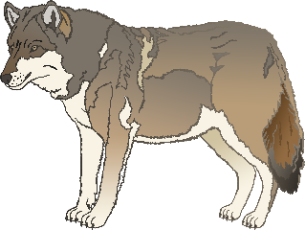

**Nursery Rooms**

Names here….

Names here….

Names here….

Names here….

Names here….

Names here….

RHINOS

Room

GIRAFFES

Room

ZEBRAS

Room

WOLVES

Room

TIGERS

Room

Lions

Room

© 2020 Little Owls Resources

© 2020 Little Owls Resources

www.littleowls-premium.com *EDITABLE Resource*



© 2020 Little Owls Resources

www.littleowls-premium.com *EDITABLE Resource*



**Lions Room**

Names here….

**Tigers room**

Names here….

Names here….

Names here….

© 2020 Little Owls Resources

© 2020 Little Owls Resources

© 2020 Little Owls Resources

www.littleowls-premium.com *EDITABLE Resource*



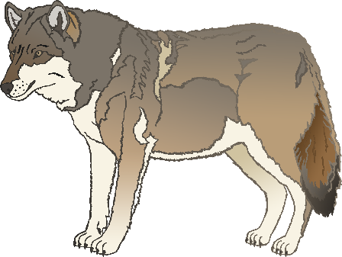

Names here….

Names here….

**Zebras room**

Names here….

**Wolves room**

Names here….

© 2020 Little Owls Resources

© 2020 Little Owls Resources

Names here….

Names here….

**Rhinos room**

Names here….

**Giraffes room**

Names here….

© 2020 Little Owls Resources

© 2020 Little Owls Resources

© 2020 Little Owls Resources

www.littleowls-premium.com *EDITABLE Resource*

