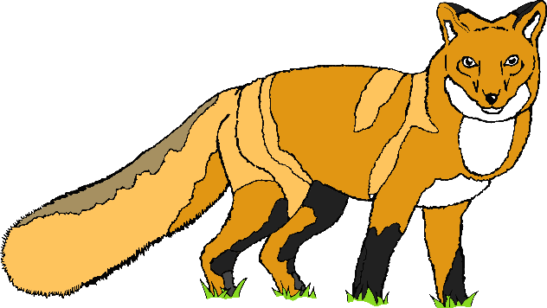

© 2019 Little Owls Resources

© 2019 Little Owls Resources

1

1

1

1

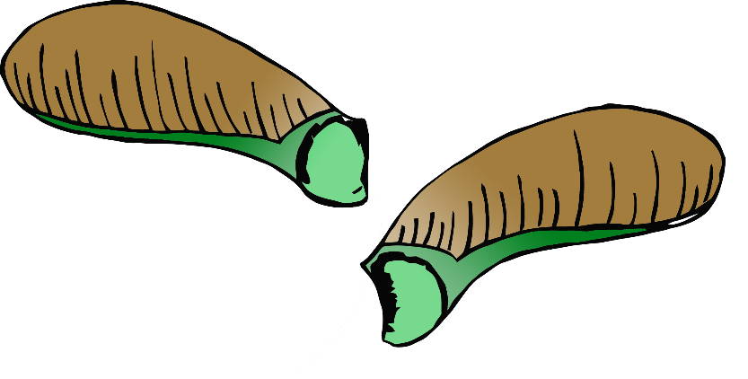

© 2019 Little Owls Resources

© 2019 Little Owls Resources

2

2

2

2

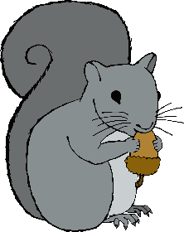

© 2019 Little Owls Resources

© 2019 Little Owls Resources

3

3

3

3

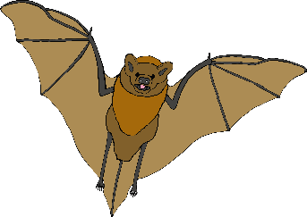

4

4

4

4



© 2019 Little Owls Resources

© 2019 Little Owls Resources



5

5

5

5



© 2019 Little Owls Resources

© 2019 Little Owls Resources

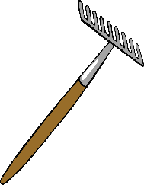

6

6

6

6



© 2019 Little Owls Resources

© 2019 Little Owls Resources

7

7

7

7



© 2019 Little Owls Resources

© 2019 Little Owls Resources



© 2019 Little Owls Resources

© 2019 Little Owls Resources

www.littleowlsresources.com

8

8

8

8

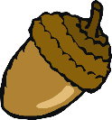

9

9

9

9

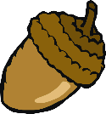

© 2019 Little Owls Resources

© 2019 Little Owls Resources



10

10

10

10



© 2019 Little Owls Resources

© 2019 Little Owls Resources