**Autumn** Sounds

Prompt Cards

These cards can be used to prompt a discussion about the sounds heard in autumn.

This discussion could be before, after or during an autumn walk!

© 2022 Little Owls Resources

© 2022 Little Owls Resources

**Autumn** Sounds

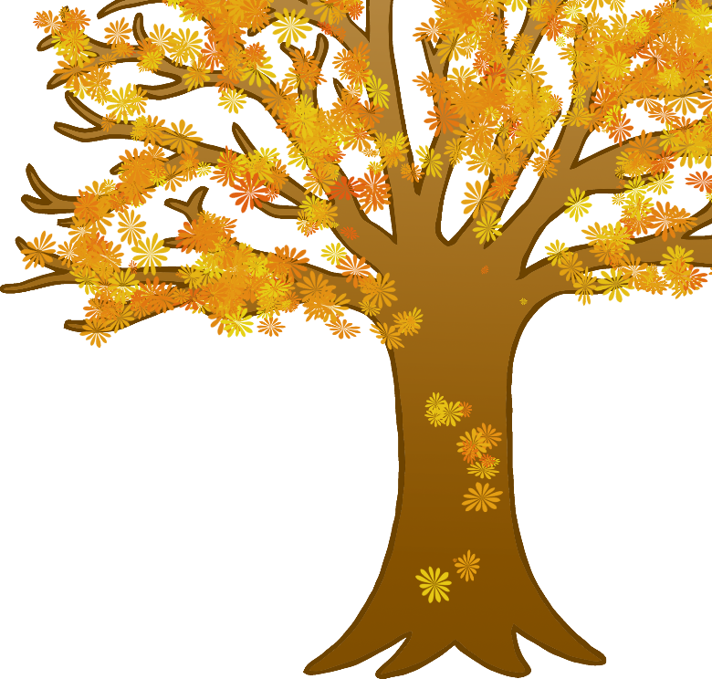

scrape



© 2022 Little Owls Resources

**Autumn** Sounds



splash



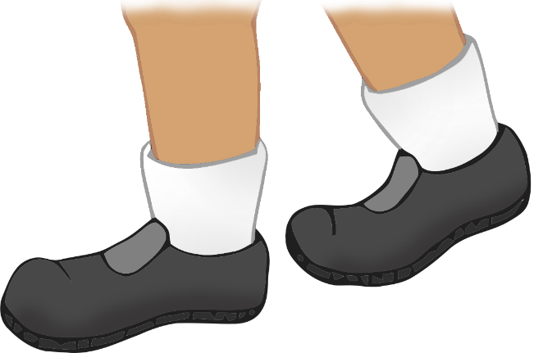

© 2022 Little Owls Resources

**Autumn** Sounds



crunch

© 2022 Little Owls Resources

**Autumn** Sounds



tap

© 2022 Little Owls Resources

**Autumn** Sounds



crack

© 2022 Little Owls Resources

**Autumn** Sounds



rustle

© 2022 Little Owls Resources

**Autumn** Sounds



tweet

© 2022 Little Owls Resources

**Autumn** Sounds



whoosh

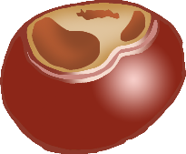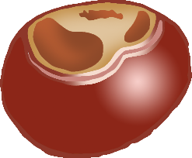

© 2022 Little Owls Resources

**Autumn** Sounds



clack

© 2022 Little Owls Resources

**Autumn** Sounds



pitter-patter

© 2022 Little Owls Resources

**Autumn** Sounds



clip clop

© 2022 Little Owls Resources

**Autumn** Sounds



quack

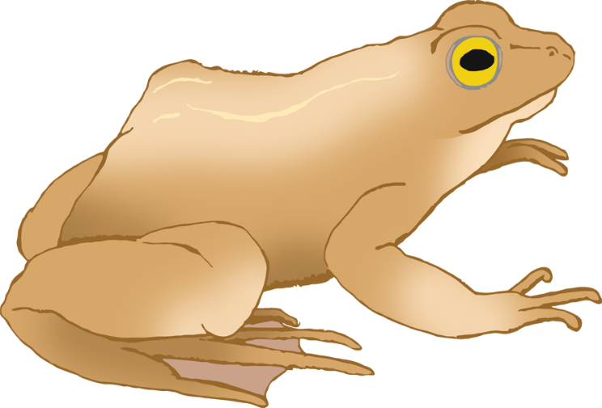

© 2022 Little Owls Resources

**Autumn** Sounds



croak

© 2022 Little Owls Resources

**Autumn** Sounds



buzz

© 2022 Little Owls Resources

**Autumn** Sounds



woof

© 2022 Little Owls Resources

**Autumn** Sounds



meow