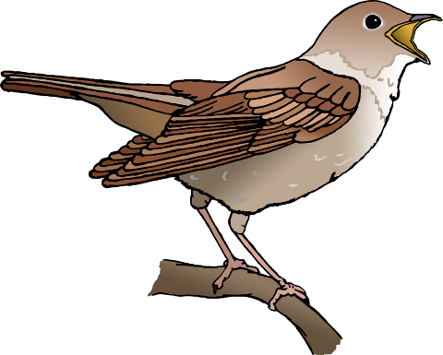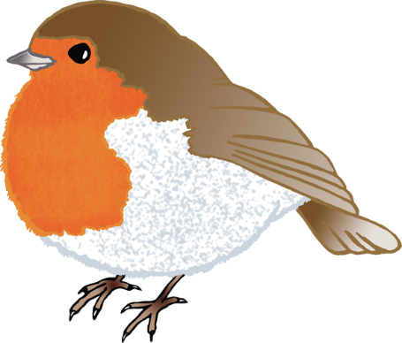

Birds

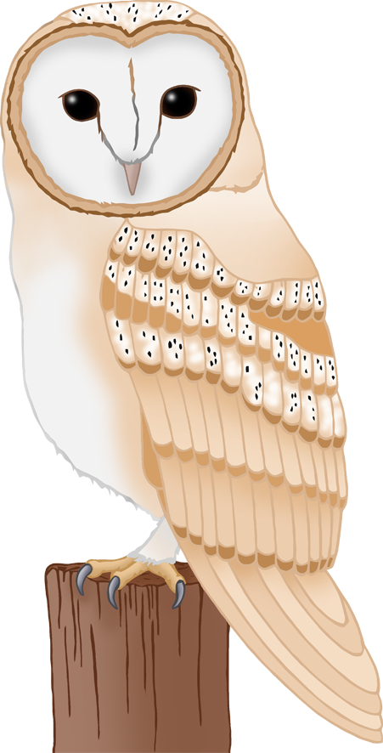

© 2022 Little Owls Resources