Badger footprint in the snow - multimat

© 2022 Little Owls Resources



Fox footprint in the snow - multimat

© 2022 Little Owls Resources



Squirrel footprint in the snow - multimat

© 2022 Little Owls Resources



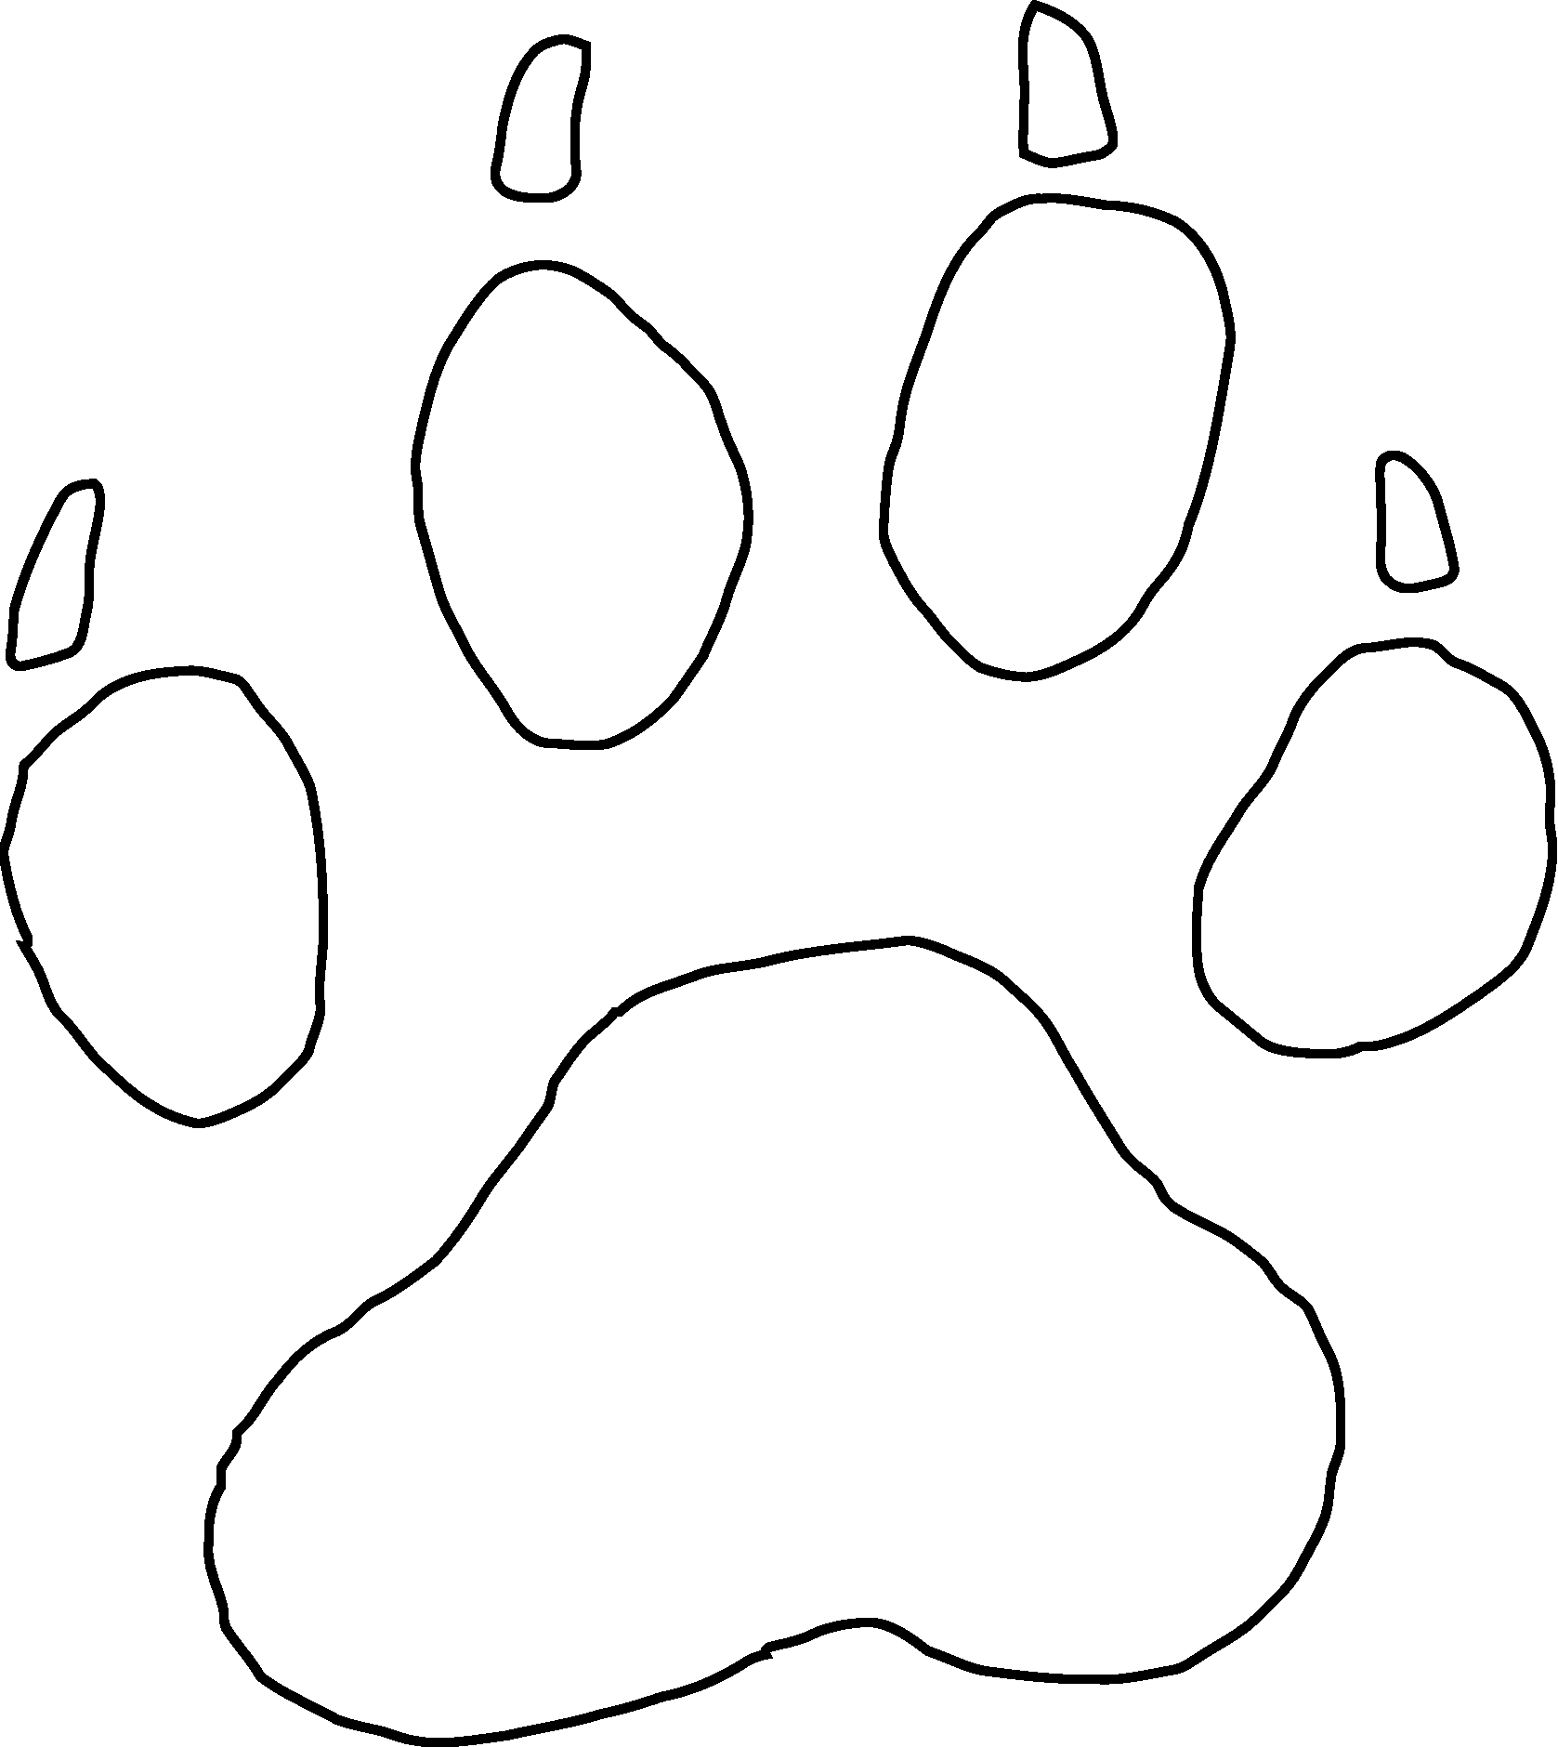

Dog footprint in the snow - multimat

© 2022 Little Owls Resources



Deer footprint in the snow - multimat

© 2022 Little Owls Resources



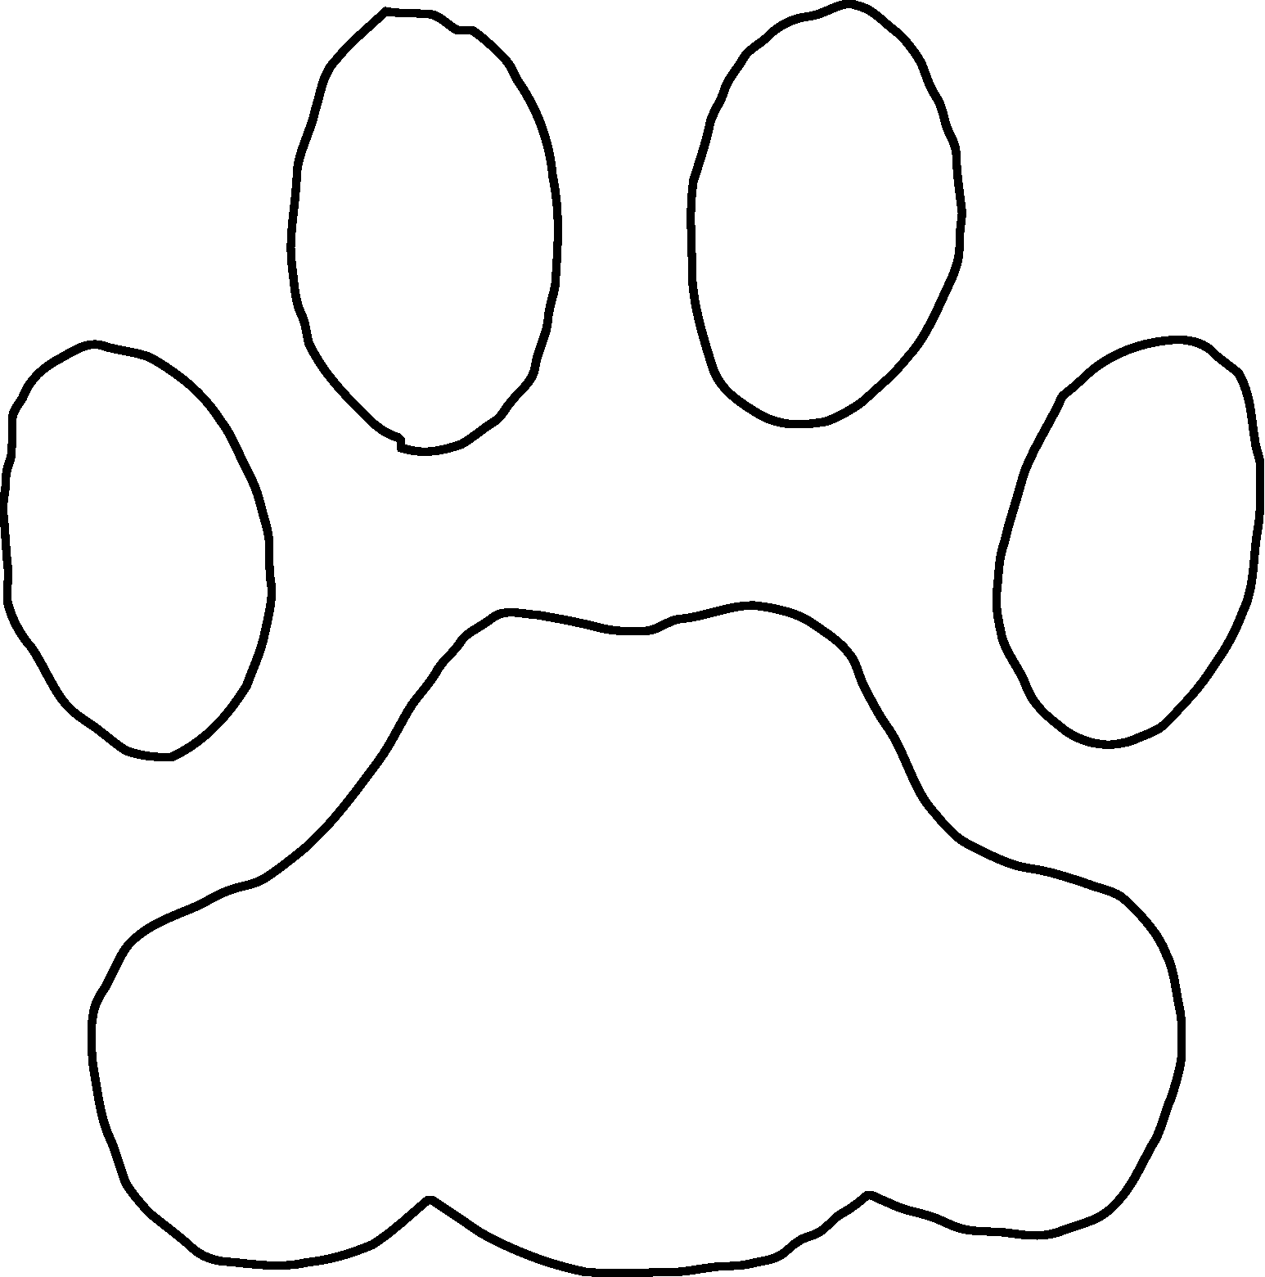

Cat footprint in the snow - multimat

© 2022 Little Owls Resources

