Blackbird

© 2021 Little Owls Resources

© 2021 Little Owls Resources

Blackbird

Blackbird

© 2021 Little Owls Resources

© 2021 Little Owls Resources

Blackbird

Pigeon

© 2021 Little Owls Resources

© 2021 Little Owls Resources

Pigeon

Pigeon

© 2021 Little Owls Resources

© 2021 Little Owls Resources

Pigeon

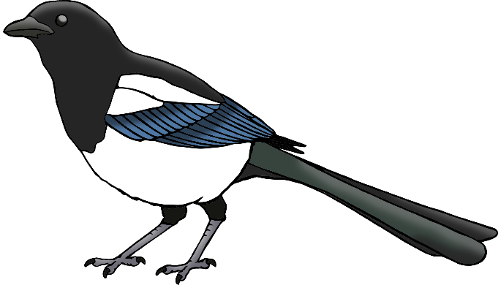

Magpie

© 2021 Little Owls Resources

© 2021 Little Owls Resources

Magpie



Magpie

© 2021 Little Owls Resources

© 2021 Little Owls Resources

Magpie

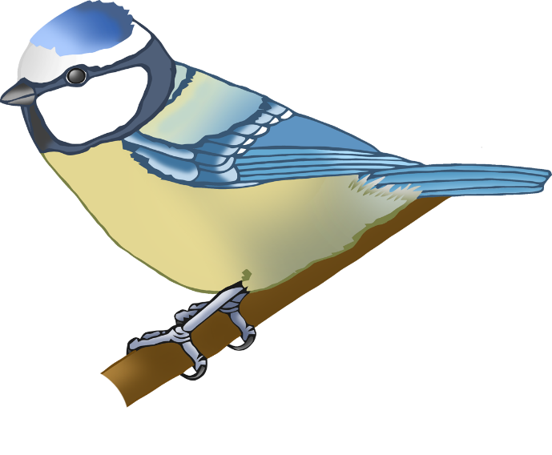

Blue Tit

Blue Tit

© 2021 Little Owls Resources

© 2021 Little Owls Resources



Blue Tit

Blue Tit

© 2021 Little Owls Resources

Owls Resources

© 2021 Little Owls Resources

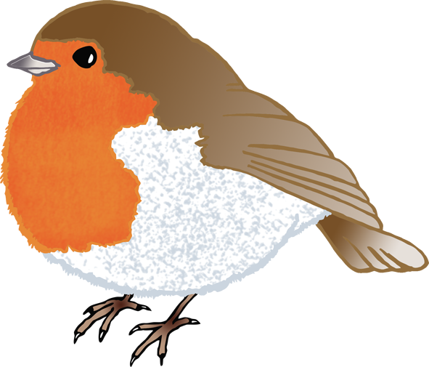

Robin

© 2021 Little Owls Resources

© 2021 Little Owls Resources

Robin



Robin

© 2021 Little Owls Resources

© 2021 Little Owls Resources

Robin