Hey Diddle Diddle

© 2019 Little Owls Resources

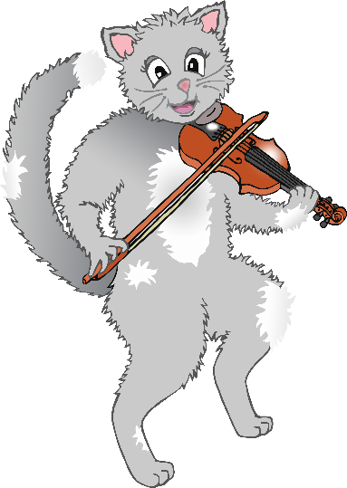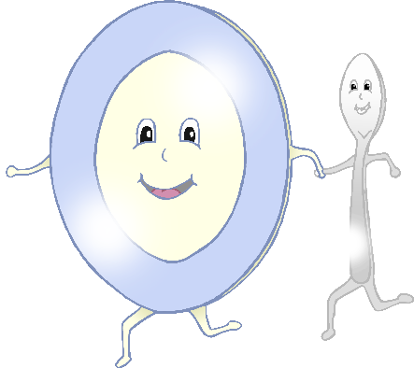

Hey diddle diddle,

the cat and the fiddle,

the cow jumped over the moon.

The little dog laughed,

to see such fun,

and the dish ran away with the spoon.

Hey Diddle Diddle

© 2019 Little Owls Resources



Hey diddle diddle,

the cat and the fiddle,

the cow jumped over the moon.

The little dog laughed,

to see such fun,

and the dish ran away with the spoon.

Hey Diddle Diddle

© 2019 Little Owls Resources



Hey diddle diddle,

the cat and the fiddle,

the cow jumped over the moon.

The little dog laughed,

to see such fun,

and the dish ran away with the spoon.

Hey Diddle Diddle

© 2019 Little Owls Resources



Hey diddle diddle,

the cat and the fiddle,

the cow jumped over the moon.

The little dog laughed,

to see such fun,

and the dish ran away with the spoon.