George’s Reward Chart

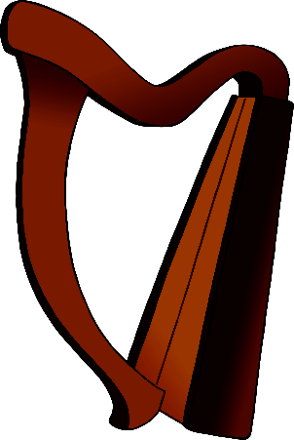

**My Target:**

To eat all my lunch every day.

© 2021 Little Owls Resources

© 2021 Little Owls Resources

To eat all my lunch every day.

**My Target:**

George’s Reward Chart

