**Winter Senses**

**My**

**Booklet**

© 2020 Little Owls Resources

© 2020 Little Owls Resources

In **Winter** I can smell…

© 2020 Little Owls Resources

In **Winter** I can feel…

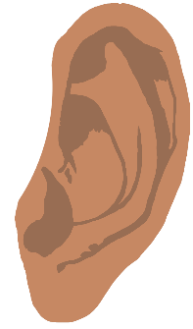

© 2020 Little Owls Resources

In **Winter** I can hear…

© 2020 Little Owls Resources

In **Winter** I can see…

© 2020 Little Owls Resources

In **Winter** I can taste…