These letter sheets are intended to aid young children in their familiarity with their initial letter.

Included are all the letters of the alphabet in capitals. These could be used for basic colouring or as the starting point for some collage work.

Name letter outlines

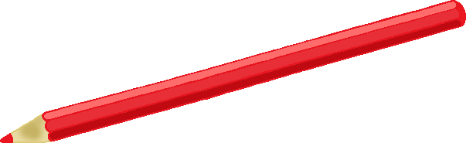

My name starts with…

My name starts with…

My name starts with…

My name starts with…

My name starts with…

My name starts with…

My name starts with…

My name starts with…

My name starts with…

My name starts with…

My name starts with…

My name starts with…

My name starts with…

My name starts with…

My name starts with…

My name starts with…

My name starts with…

My name starts with…

My name starts with…

My name starts with…

My name starts with…

My name starts with…

My name starts with…

My name starts with…

My name starts with…

My name starts with…