**Busy Learners Preschool**

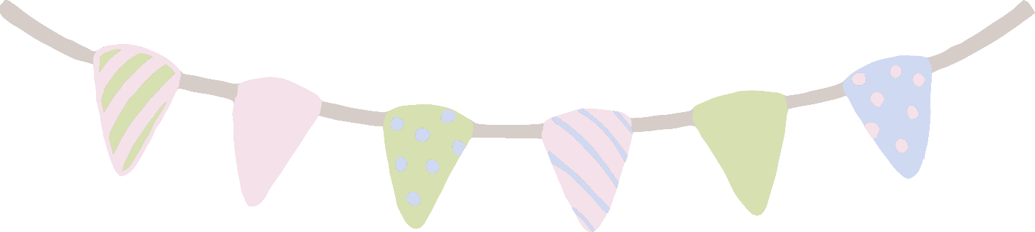

© 2020 Little Owls Resources

**Our**

**Rules**

Your rules here…

Your rules here…

Your rules here…

Your rules here…