STEM

Challenge support materials

p2: Challenge/Questions card

p3-4: Posters

p5: Practitioner notes

p6-8: Word cards (&blanks) (for display or as flash cards)

p9-11: ‘What did we do?’ sheets (for writing, drawing, or adding a photograph)

p12-14: ‘My experiment’ sheets (for writing, drawing, or adding a photograph)

**Make a shadow**

**This pack includes…**

© 2022 Little Owls Resources

© 2022 Little Owls Resources

STEM

Can you…

…make a shadow?

Challenge

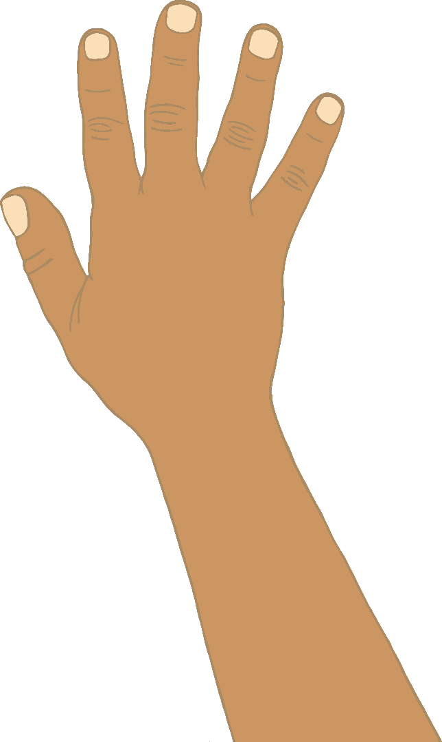

© 2022 Little Owls Resources

STEM

Questions

Can you make the shadow bigger?

Can you make the shadow smaller?

Can you make different shadow shapes?

What happens when you move the light?

?

?

?

Shadows

shadow

tree (object)

sun (light)

© 2022 Little Owls Resources

Shadows

Shadows

pencil (object)

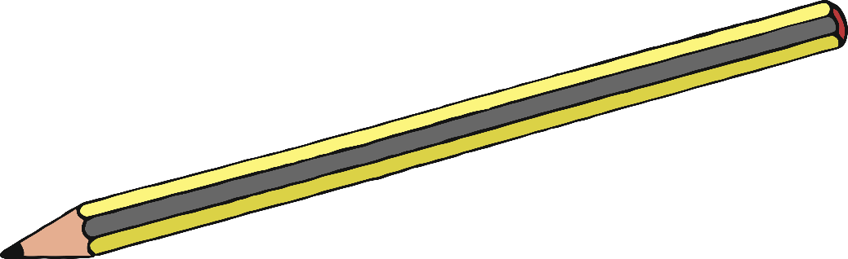

shadow

lamp (light)

© 2022 Little Owls Resources

* Torch or Lamp
* Different shaped objects
* A sunny day!

**Items that might be useful**

Practitioner notes

**Make a shadow**

STEM

Encourage a short discussion about shadows.

What is a shadow? – Where have you seen a shadow?

Give the children time to explore their ideas.

How will you make a shadow? – What do you need?

Allow the children to experiment with as much independence as possible. Let them discover how shadows change as you move an object or move the light source (if you can!).

How did you make the shadow bigger/smaller?

© 2022 Little Owls Resources

sunlight

shadow

© 2022 Little Owls Resources

© 2022 Little Owls Resources

© 2022 Little Owls Resources

light

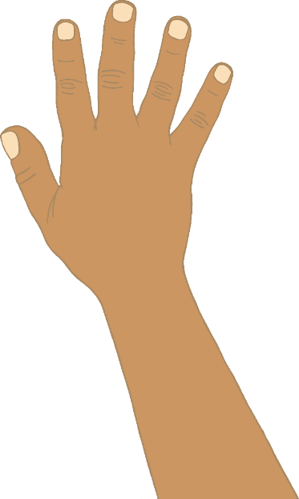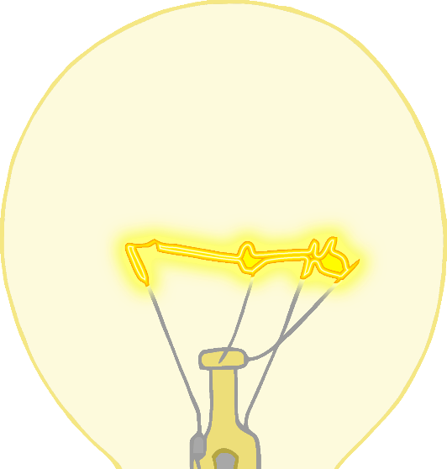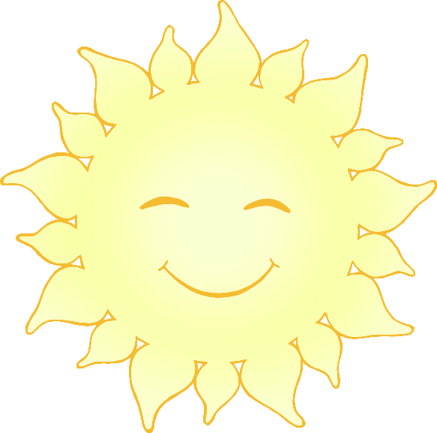

shadow

dark

torch

© 2022 Little Owls Resources

© 2022 Little Owls Resources

© 2022 Little Owls Resources

© 2022 Little Owls Resources

© 2022 Little Owls Resources

© 2022 Little Owls Resources

What did we do?

__________________________________________________________________

© 2022 Little Owls Resources

What did we do?

____________________________

© 2022 Little Owls Resources

What did we do?

© 2022 Little Owls Resources

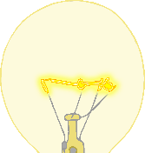

My experiment

__________________________________________________________________

© 2022 Little Owls Resources



My experiment

____________________________

© 2022 Little Owls Resources



My experiment

© 2022 Little Owls Resources