Help the turtles find their eggs!

Game for three players.

Takes turns to turn a card. If it is a rock turn the card back over. If it is an egg put it on your collection card.

The first player to get five eggs is the winner!

Turtle Egg Find

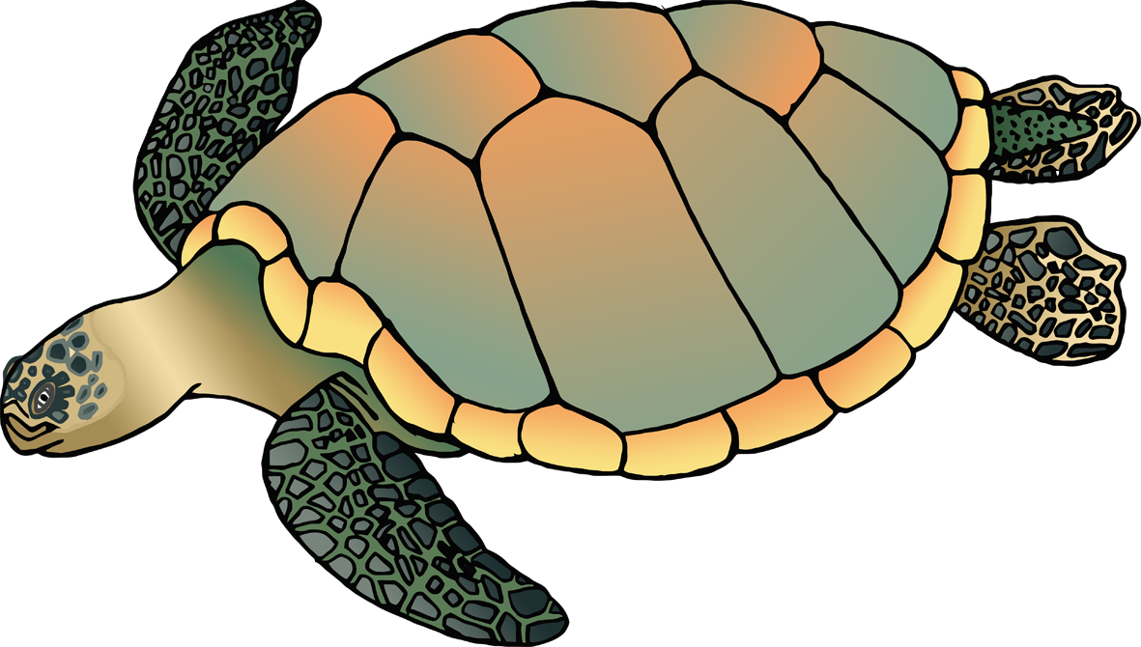

© 2020 Little Owls Resources

1

2

3

4

5



© 2020 Little Owls Resources

1

2

3

4

5



© 2020 Little Owls Resources

1

2

3

4

5



