Wales’ capital city:

Caerdydd

(Cardiff)

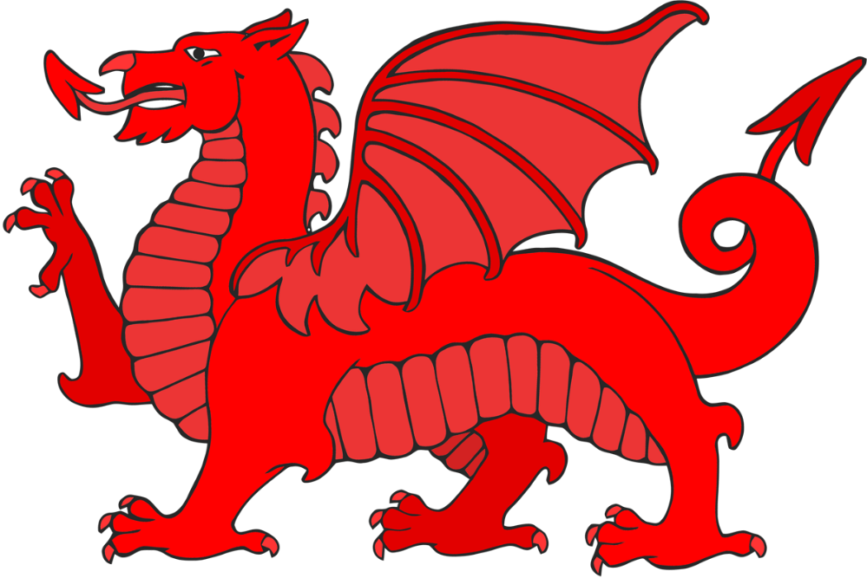

© 2020 Little Owls Resources

© 2020 Little Owls Resources

The population of Wales is approximately 3.1 million.

3,100,000

people

daffodils

leeks

The national symbols of Wales are:



© 2020 Little Owls Resources

© 2020 Little Owls Resources

The national languages of Wales are:

Cymraeg (Welsh)

&

English

Wales has three national parks:

* Pembrokeshire Coast
* Snowdonia
* Brecon Beacons

The name for Wales in Welsh is:

Cymru



© 2020 Little Owls Resources

© 2020 Little Owls Resources

football

rugby union



© 2020 Little Owls Resources

© 2020 Little Owls Resources

The most popular sports in Wales are:

Wales has over 600 castles; more castles per square mile than anywhere in the world.

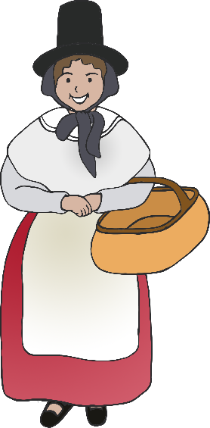

Traditional Welsh Clothing



© 2020 Little Owls Resources

© 2020 Little Owls Resources



© 2020 Little Owls Resources

© 2020 Little Owls Resources