What is a meteor?

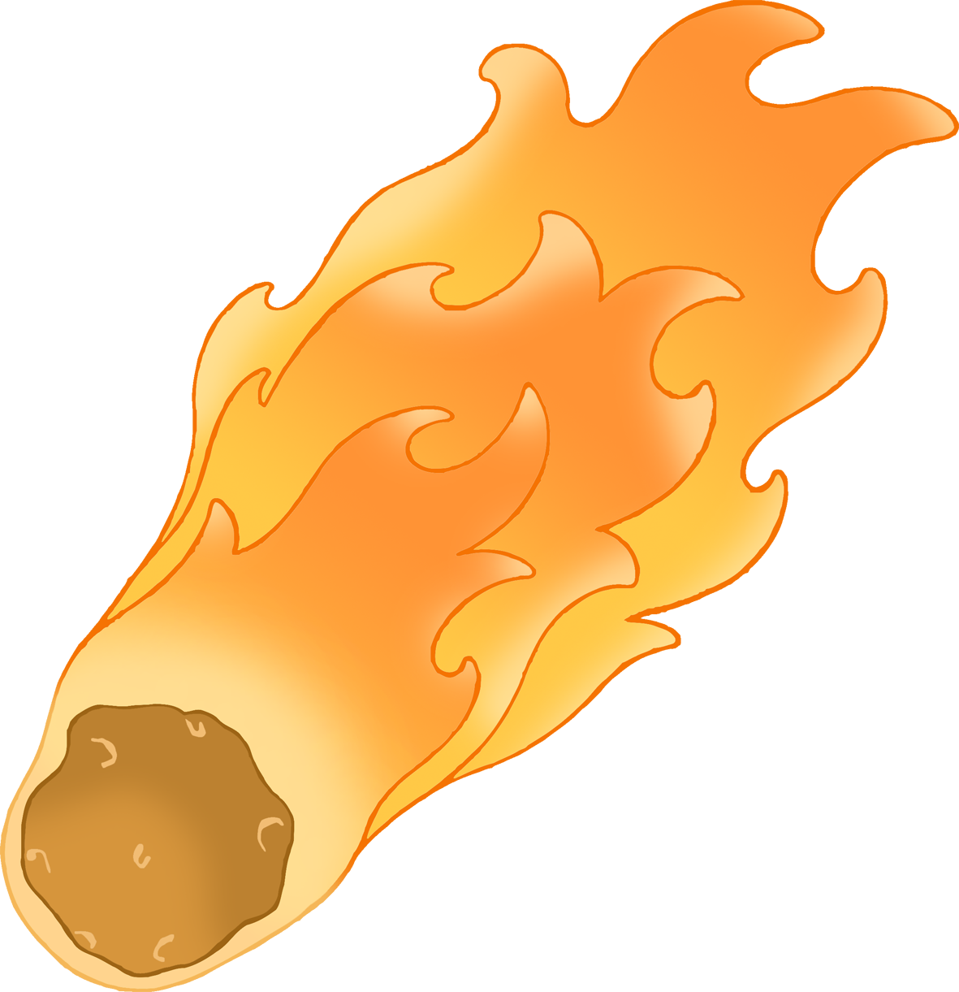

© 2021 Little Owls Resources

A meteor is a small piece of rock from space that burns up in a bright flash when it enters the atmosphere of a planet.

Some people call meteors ‘shooting stars’.