26 **Challenge Cards**

Challenges – 3 or 4-year-olds

© 2021 Little Owls Resources

This pack is intended to be used as an interactive challenge display. The first two sheets have a space that, once laminated, can have challenges written in using a whiteboard pen.

Alternatively, the challenge cards later in the pack can be cut and laminated and stuck on the display as a challenge starter.

For many of the challenges, some measure of independence is intended, however, the younger the child is the more scaffolding their learning will require.

Today’s Challenge

© 2021 Little Owls Resources

Challenge

Yourself!

© 2021 Little Owls Resources

3 or 4-year-olds

© 2021 Little Owls Resources

3 or 4-year-olds

© 2021 Little Owls Resources

Count the building blocks.

Make a picture using shapes.

Put the ball **in** the box.

Put the ball **behind** the box.

Put the ball **next to** the box.

Where else can it go?

3 or 4-year-olds

© 2021 Little Owls Resources

3 or 4-year-olds

© 2021 Little Owls Resources

Make snakes with playdough. Which is longer? Which is shorter?

Play a game of ‘Simon Says’ with a grown-up.

3 or 4-year-olds

© 2021 Little Owls Resources

Talk with a friend about your favourite food or drink.

3 or 4-year-olds

© 2021 Little Owls Resources

Pick out a book you like and tell someone about it.

3 or 4-year-olds

© 2021 Little Owls Resources

Play with some small world toys.

What are they saying to each other?

3 or 4-year-olds

© 2021 Little Owls Resources

Try something new

today!

3 or 4-year-olds

© 2021 Little Owls Resources

Do something very helpful for someone.

3 or 4-year-olds

© 2021 Little Owls Resources

Talk with a grown up about how you are feeling today.

3 or 4-year-olds

© 2021 Little Owls Resources

Look at a character in a picture book. How are they feeling?

3 or 4-year-olds

© 2021 Little Owls Resources

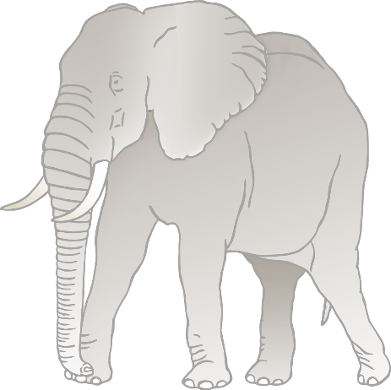

With a friend, take turns choosing an animal. Then move like that animal.

3 or 4-year-olds

© 2021 Little Owls Resources

Collect 10 small stones from the outdoor area.

3 or 4-year-olds

© 2021 Little Owls Resources

Draw 5 circles on some paper. Can you make them smaller and smaller?

3 or 4-year-olds

© 2021 Little Owls Resources

Run on the spot whilst you count to 5. Then jump 5 times. Then hop 5 times.

Now feel your heartbeat!

3 or 4-year-olds

© 2021 Little Owls Resources

Choose a book to share with a grown-up. Where is the front cover? What do you think the book is going to be about?

3 or 4-year-olds

© 2021 Little Owls Resources

Write any letters you can see around you. You could use a pencil, chalk or even your finger in wet sand!

3 or 4-year-olds

© 2021 Little Owls Resources

Collect as many different types of leaves or stones as you can.

3 or 4-year-olds

© 2021 Little Owls Resources

Talk with a friend or a grown-up about something you remember doing with your family.

3 or 4-year-olds

© 2021 Little Owls Resources

Investigate the outdoor area using a magnifying glass.

Tell someone what you saw.

3 or 4-year-olds

© 2021 Little Owls Resources

Talk with a friend about the job you would like to do when you are older, then draw yourself as a grown-up in that job.

3 or 4-year-olds

© 2021 Little Owls Resources

Sit across from a friend. Draw a picture of them whilst they draw a picture of you.

3 or 4-year-olds

© 2021 Little Owls Resources

Paint a picture of something **magical** .

3 or 4-year-olds

© 2021 Little Owls Resources

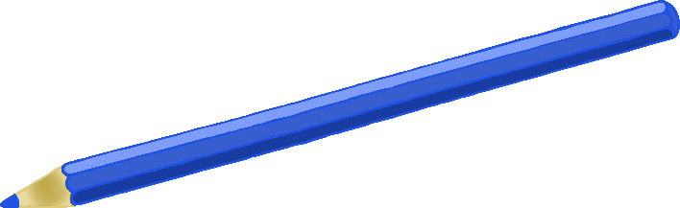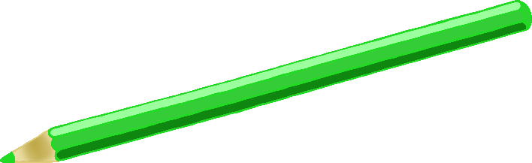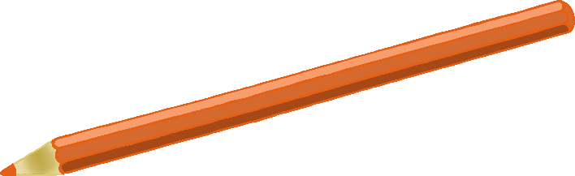

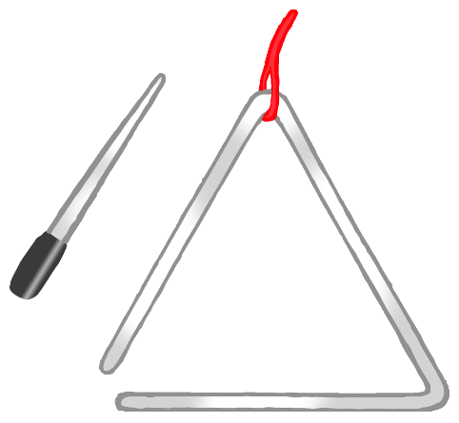

Sing your favourite song.

3 or 4-year-olds

© 2021 Little Owls Resources

Try playing three different musical instruments.

Which is your favourite? Why?

3 or 4-year-olds

© 2021 Little Owls Resources