This resource is intended to serve as inspiration for activities during the summertime. They do not need to be followed to the letter or completed in any order; they are just a starting point for summer fun!

A blank version is also included for you to add your own ideas.

Enjoy the summer!

© 2022 Little Owls Resources

30 Days of Summer!

Which will you choose?

30 Days of Summer!

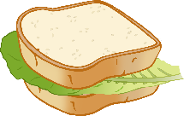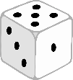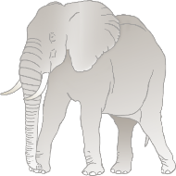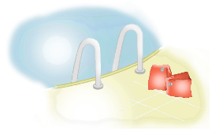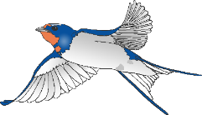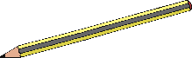

Investigate with a magnet!

Tell some jokes!

Create some fingerpaint art!

Build a house using building blocks!

Meet a friend at the park!

Visit a library!

Find a minibeast!

Find a rockpool!

Have a picnic!

Draw a bird!

Create a junk model rocket!

Do a jigsaw!

Make roads for cars!

Play a game with dice!

Go for a run!

Make some music!

Do some cooking!

Paint a picture of some flowers!

Play a ball game!

Build a sandcastle!

Make a sandwich!

Draw a tree!

Create with playdough!

Make a mud pie!

Paint with water!

Go on a nature walk!

Go swimming!

Visit the zoo!

Collect shells at the beach!

Build a dinosaur world!

© 2022 Little Owls Resources

**25**

**26**

**27**

**28**

**29**

**30**

**19**

**20**

**21**

**22**

**23**

**24**

**13**

**14**

**15**

**16**

**17**

**18**

**7**

**8**

**9**

**10**

**11**

**12**

**1**

**2**

**3**

**4**

**5**

**6**

**7**

**8**

**9**

**10**

**11**

**12**

**13**

**14**

**15**

**16**

**17**

**18**

**19**

**20**

**21**

**22**

**23**

**24**

**25**

**26**

**27**

**28**

**29**

**30**

30 Days of Summer!

© 2022 Little Owls Resources

**1**

**2**

**3**

**4**

**5**

**6**