20 **Challenge Cards**

Challenges – Birth to 3

© 2021 Little Owls Resources

This pack is intended to be used as an interactive challenge display. The first two sheets have a space that, once laminated, can have challenges written in using a whiteboard pen.

Alternatively, the challenge cards later in the pack can be cut and laminated and stuck on the display as a challenge starter.

For many of the challenges, some measure of independence is intended, however, the younger the child is the more scaffolding their learning will require.

Today’s Challenge

© 2021 Little Owls Resources

Challenge

Yourself!

© 2021 Little Owls Resources

Build a tower with blocks.

Birth to 3

© 2021 Little Owls Resources

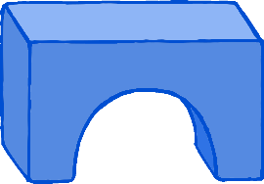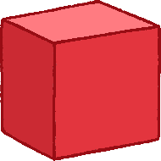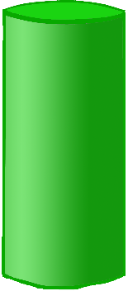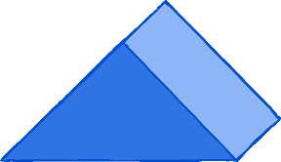

Separate big from small.

Birth to 3

© 2021 Little Owls Resources

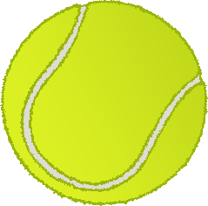

Sing a song or rhyme with a grown-up. Don’t forget the actions!

Birth to 3

© 2021 Little Owls Resources

Play with some small world toys.

What are the names of the toys?

Birth to 3

© 2021 Little Owls Resources

Look at a picture book with a grown-up.

What can you see in the book?

Birth to 3

© 2021 Little Owls Resources

Pretend two toys are having a picnic together. What do they say to each other?

Birth to 3

© 2021 Little Owls Resources

Tell a grown-up how you are feeling.

Birth to 3

© 2021 Little Owls Resources

Look in a mirror.

Make a sad face.

Make a happy face.

Birth to 3

© 2021 Little Owls Resources

Count to 10 whilst jumping on the spot.

Birth to 3

© 2021 Little Owls Resources

Can you move your body very s l o w l y ?

Birth to 3

© 2021 Little Owls Resources

Pick up a beanbag.

Pat it three times.

Throw the beanbag!

Birth to 3

© 2021 Little Owls Resources

In the outdoor area sit still and quiet for 10 seconds.

Then jump for 10 seconds!

Birth to 3

© 2021 Little Owls Resources

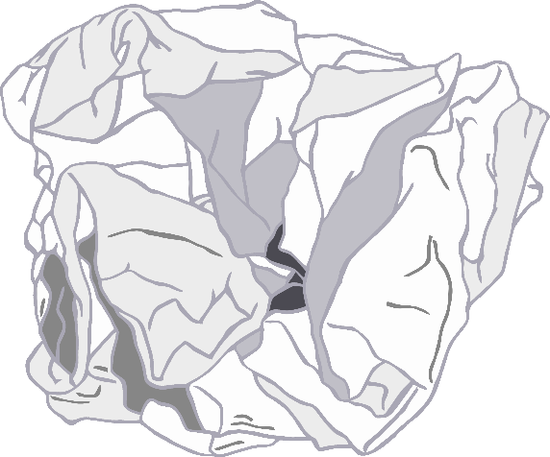

Make some marks on a piece of paper.

Then scrunch it up into a ball.

Then open up the paper again to find your picture.

Birth to 3

© 2021 Little Owls Resources

Stick some building bricks together.

How many bricks did you use?

What colours are there?

Birth to 3

© 2021 Little Owls Resources

Choose a book and share it with a grown-up.

Birth to 3

© 2021 Little Owls Resources

Make marks in some wet sand.

Can you make some shapes?

Birth to 3

© 2021 Little Owls Resources

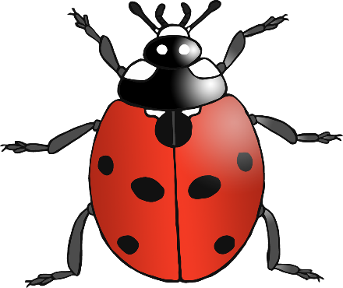

Explore wet and dry sand with your hands…. And feet!

Birth to 3

© 2021 Little Owls Resources

Find a minibeast in the outdoor area.

Birth to 3

© 2021 Little Owls Resources

Sing a fast song with a grown-up.

Sing a s l o w song with a grown up.

Birth to 3

© 2021 Little Owls Resources

Make some marks in the outdoor area. Will you use chalk? Or a stick in the mud? Or something else?

Birth to 3

© 2021 Little Owls Resources