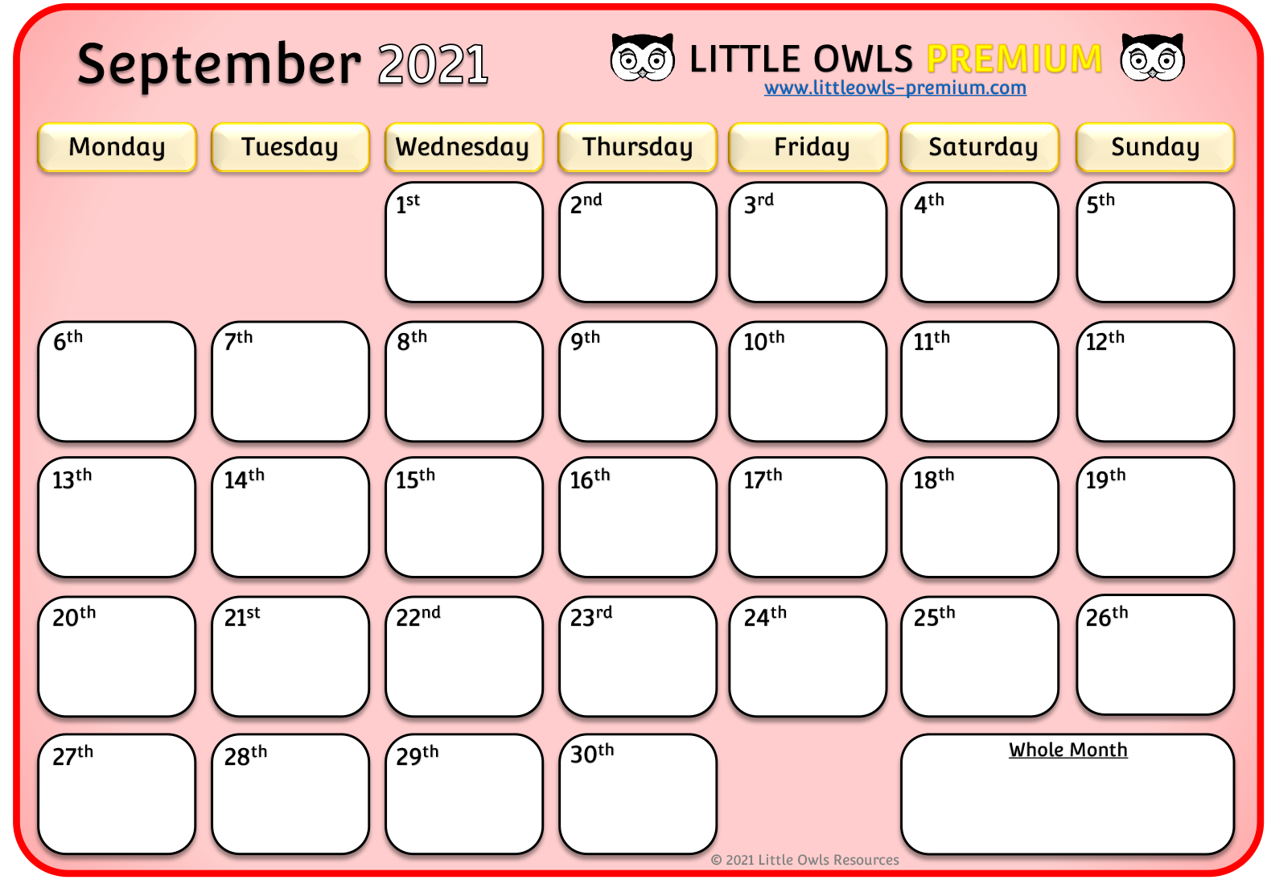

**Notes**

© 2021 Little Owls Resources

**Notes**

© 2021 Little Owls Resources

**Notes**

© 2021 Little Owls Resources

**Notes**

© 2021 Little Owls Resources

**Notes**

© 2021 Little Owls Resources

**Notes**

© 2021 Little Owls Resources

**Notes**

© 2021 Little Owls Resources

**Notes**

© 2021 Little Owls Resources

**Notes**

© 2021 Little Owls Resources

**Notes**

© 2021 Little Owls Resources

**Notes**

© 2021 Little Owls Resources

**Notes**

© 2021 Little Owls Resources

**Notes**

© 2021 Little Owls Resources

**Notes**

© 2021 Little Owls Resources