Dingle Dangle

Nursery Rhymes

Scarecrow

* Sequence cards (8)
* Cut & match sequence cards (4)
* Illustration activity sheets (5)
* Landscape lyrics poster (1)
* Landscape lyrics poster – colouring (1)
* Portrait lyrics poster (1)
* Portrait lyrics poster – colouring (1)
* A6 lyrics sheets (1)
* Scarecrow colouring sheet (1)

This pack includes:

(Number of A4 pages in brackets)

© 2023 Little Owls Resources

© 2023 Little Owls Resources

When all the cows were sleeping…

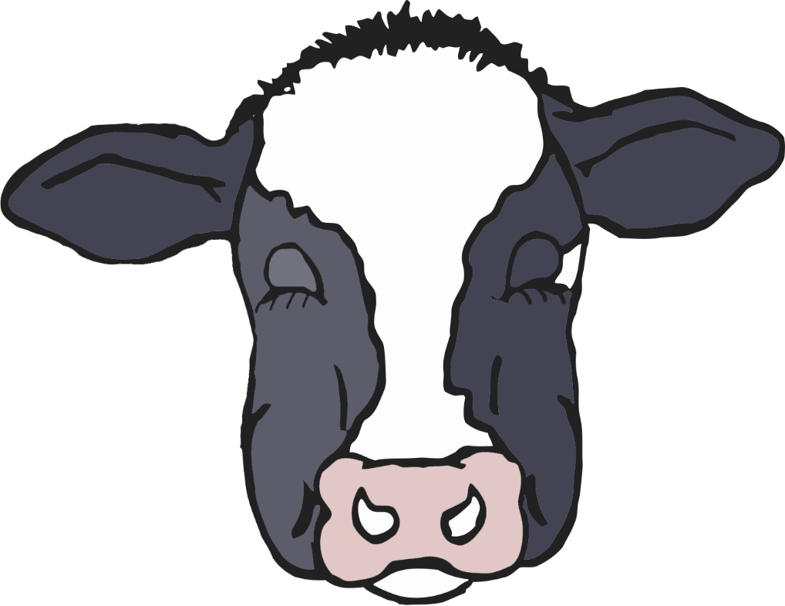

Z

Z

Z

© 2023 Little Owls Resources



And the sun had gone to bed…

© 2023 Little Owls Resources

Up jumped the scarecrow and this is what he said…

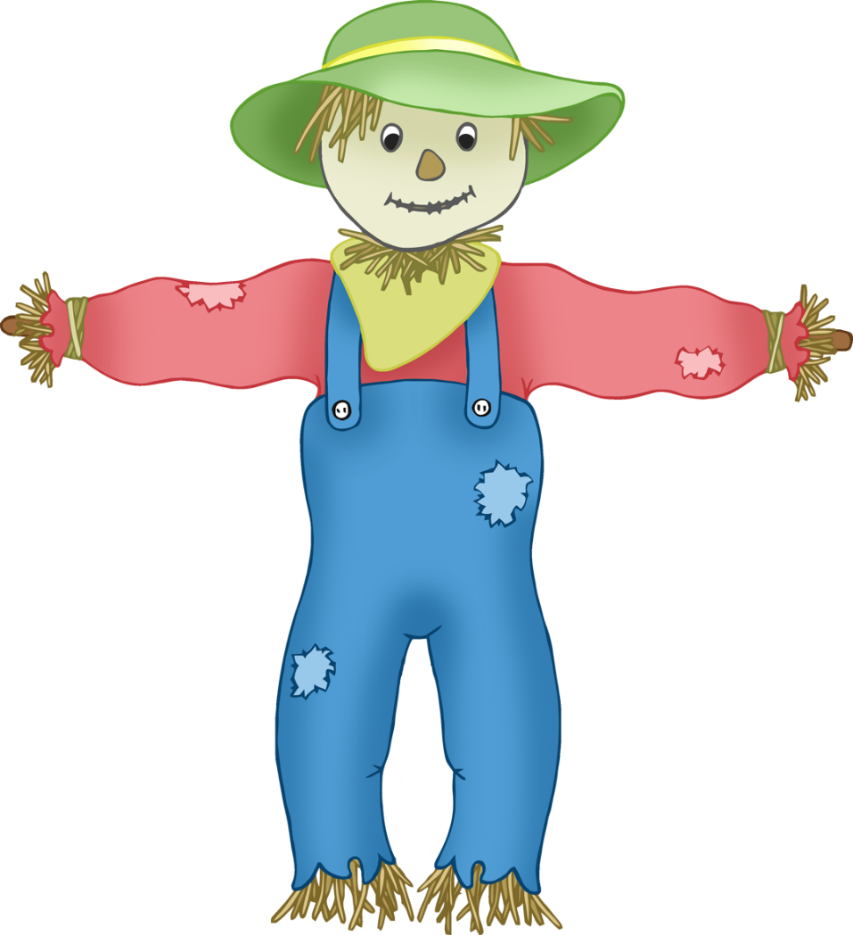

© 2023 Little Owls Resources

“I'm a Dingle Dangle Scarecrow with a flippy floppy hat, I can shake my hands like this, I can shake my feet like that.”

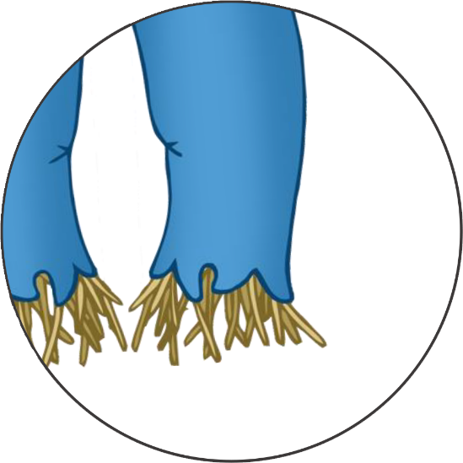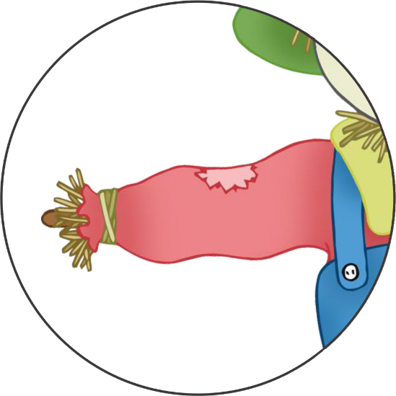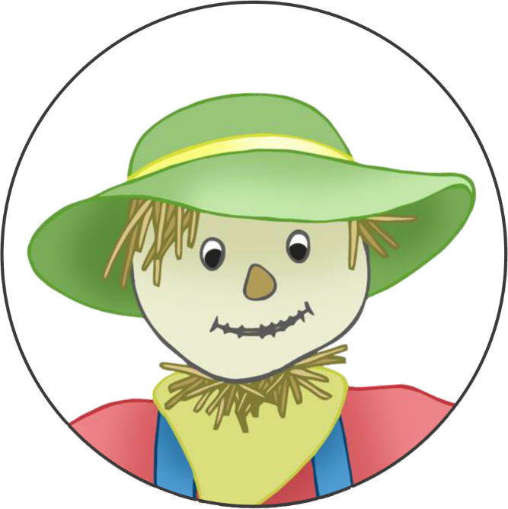

Z

Z

Z

Z

© 2023 Little Owls Resources

When all the hens were roosting…

© 2023 Little Owls Resources

And the moon’s behind the clouds...

© 2023 Little Owls Resources

Up jumped the scarecrow… and this is what he said…



© 2023 Little Owls Resources

“I'm a Dingle Dangle Scarecrow with a flippy floppy hat, I can shake my hands like this, I can shake my feet like that.”



Z

© 2023 Little Owls Resources

© 2023 Little Owls Resources

© 2023 Little Owls Resources

© 2023 Little Owls Resources

Z

Z

Z

Z

Z

© 2023 Little Owls Resources

© 2023 Little Owls Resources

© 2023 Little Owls Resources

© 2023 Little Owls Resources

When all the cows were sleeping…

© 2023 Little Owls Resources

And the sun had gone to bed…

© 2023 Little Owls Resources

Up jumped the scarecrow and this is what he said…

© 2023 Little Owls Resources

“I'm a Dingle Dangle Scarecrow with a flippy floppy hat, I can shake my hands like this, I can shake my feet like that.”

© 2023 Little Owls Resources

When all the hens were roosting…

© 2023 Little Owls Resources

And the moon’s behind the clouds...

© 2023 Little Owls Resources

Up jumped the scarecrow and this is what he said…

© 2023 Little Owls Resources

“I'm a Dingle Dangle Scarecrow with a flippy floppy hat, I can shake my hands like this, I can shake my feet like that.”

© 2023 Little Owls Resources

© 2023 Little Owls Resources

When all the cows were sleeping, and the sun had gone to bed.

Dingle Dangle Scarecrow

Illustration Activity

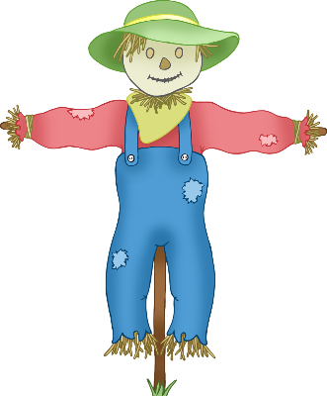

© 2023 Little Owls Resources

Up jumped the scarecrow!

Dingle Dangle Scarecrow

Illustration Activity



© 2023 Little Owls Resources

When all the hens were roosting, and the moon’s behind the clouds.

Dingle Dangle Scarecrow

Illustration Activity



© 2023 Little Owls Resources

“I'm a Dingle Dangle Scarecrow with a flippy floppy hat, I can shake my hands like this, I can shake my feet like that.”

Dingle Dangle Scarecrow

Illustration Activity



© 2023 Little Owls Resources

Dingle Dangle Scarecrow

Illustration Activity



When all the cows were sleeping

And the sun had gone to bed

Up jumped the scarecrow

And this is what he said!

“I'm a Dingle Dangle Scarecrow.

With a flippy floppy hat.

I can shake my hands like this.

I can shake my feet like that.”

When all the hens were roosting

And the moon's behind the clouds

Up jumped the scarecrow

And this is what he said!

“I'm a Dingle Dangle Scarecrow.

With a flippy floppy hat.

I can shake my hands like this.

I can shake my feet like that.”

Dingle Dangle

Scarecrow

© 2023 Little Owls Resources

Dingle Dangle

**When all the cows were sleeping**

**And the sun had gone to bed**

**Up jumped the scarecrow**

**And this is what he said!**

**“I'm a Dingle Dangle Scarecrow.**

**With a flippy floppy hat.**

**I can shake my hands like this.**

**I can shake my feet like that.”**

**When all the hens were roosting**

**And the moon's behind the clouds**

**Up jumped the scarecrow**

**And this is what he said!**

**“I'm a Dingle Dangle Scarecrow.**

**With a flippy floppy hat.**

**I can shake my hands like this.**

**I can shake my feet like that.”**

© 2023 Little Owls Resources

\

Scarecrow

Dingle Dangle

When all the cows were sleeping

And the sun had gone to bed

Up jumped the scarecrow

And this is what he said!

“I'm a Dingle Dangle Scarecrow.

With a flippy floppy hat.

I can shake my hands like this.

I can shake my feet like that.”

When all the hens were roosting

And the moon's behind the clouds

Up jumped the scarecrow

And this is what he said!

“I'm a Dingle Dangle Scarecrow.

With a flippy floppy hat.

I can shake my hands like this.

I can shake my feet like that.”

Scarecrow

© 2023 Little Owls Resources

Dingle Dangle

**When all the cows were sleeping**

**And the sun had gone to bed**

**Up jumped the scarecrow**

**And this is what he said!**

**“I'm a Dingle Dangle Scarecrow.**

**With a flippy floppy hat.**

**I can shake my hands like this.**

**I can shake my feet like that.”**

**When all the hens were roosting**

**And the moon's behind the clouds**

**Up jumped the scarecrow**

**And this is what he said!**

**“I'm a Dingle Dangle Scarecrow.**

**With a flippy floppy hat.**

**I can shake my hands like this.**

**I can shake my feet like that.”**

Scarecrow

© 2023 Little Owls Resources

Dingle Dangle Scarecrow

When all the cows were sleeping

And the sun had gone to bed

Up jumped the scarecrow

And this is what he said!

I'm a Dingle Dangle Scarecrow.

With a flippy floppy hat.

I can shake my hands like this.

I can shake my feet like that.

*

When all the hens were roosting

And the moon's behind the clouds

Up jumped the scarecrow

And this is what he said!

*

“I’m a Dingle Dangle Scarecrow.

With a flippy floppy hat.

I can shake my hands like this.

I can shake my feet like that.

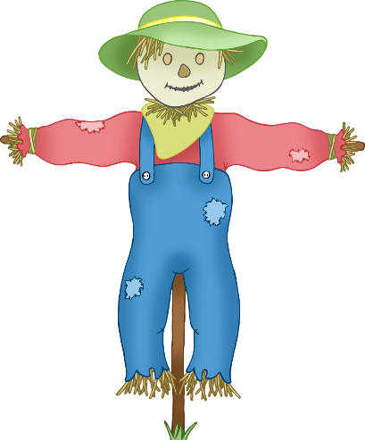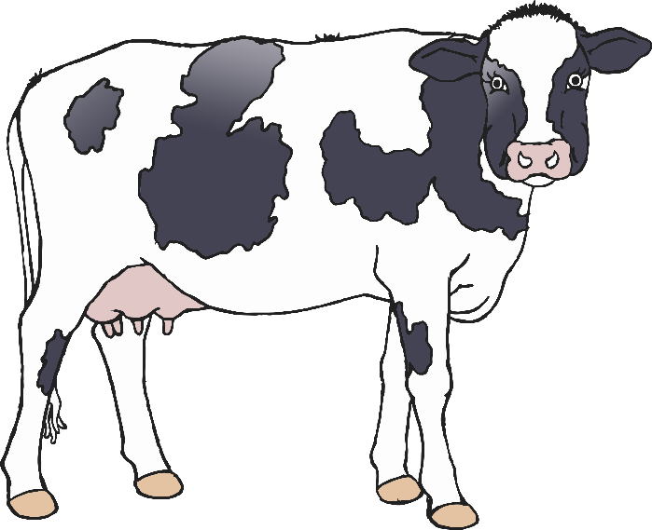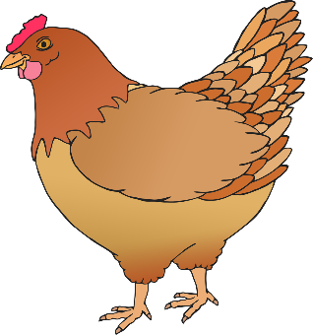

Dingle Dangle Scarecrow

When all the cows were sleeping

And the sun had gone to bed

Up jumped the scarecrow

And this is what he said!

I'm a Dingle Dangle Scarecrow.

With a flippy floppy hat.

I can shake my hands like this.

I can shake my feet like that.

*

When all the hens were roosting

And the moon's behind the clouds

Up jumped the scarecrow

And this is what he said!

*

“I’m a Dingle Dangle Scarecrow.

With a flippy floppy hat.

I can shake my hands like this.

I can shake my feet like that.



Dingle Dangle Scarecrow

When all the cows were sleeping

And the sun had gone to bed

Up jumped the scarecrow

And this is what he said!

I'm a Dingle Dangle Scarecrow.

With a flippy floppy hat.

I can shake my hands like this.

I can shake my feet like that.

*

When all the hens were roosting

And the moon's behind the clouds

Up jumped the scarecrow

And this is what he said!

*

“I’m a Dingle Dangle Scarecrow.

With a flippy floppy hat.

I can shake my hands like this.

I can shake my feet like that.



Dingle Dangle Scarecrow

When all the cows were sleeping

And the sun had gone to bed

Up jumped the scarecrow

And this is what he said!

I'm a Dingle Dangle Scarecrow.

With a flippy floppy hat.

I can shake my hands like this.

I can shake my feet like that.

*

When all the hens were roosting

And the moon's behind the clouds

Up jumped the scarecrow

And this is what he said!

*

“I’m a Dingle Dangle Scarecrow.

With a flippy floppy hat.

I can shake my hands like this.

I can shake my feet like that.



© 2023 Little Owls Resources

© 2023 Little Owls Resources

© 2023 Little Owls Resources

© 2023 Little Owls Resources

Dingle Dangle Scarecrow

© 2023 Little Owls Resources