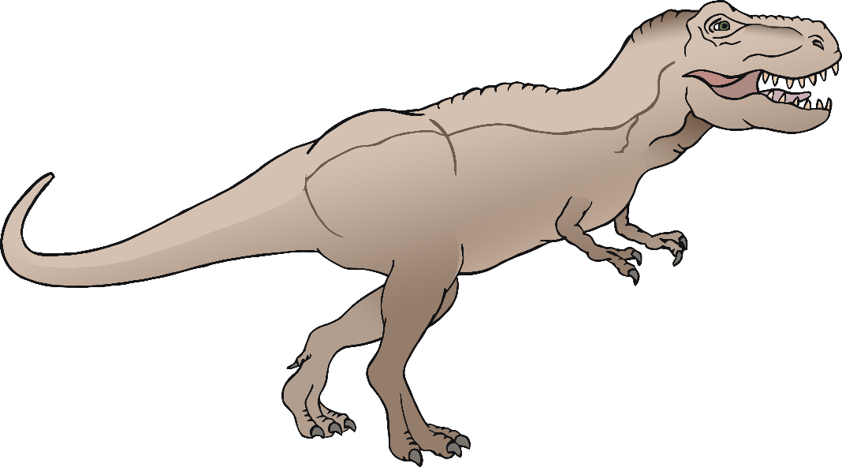

1

2

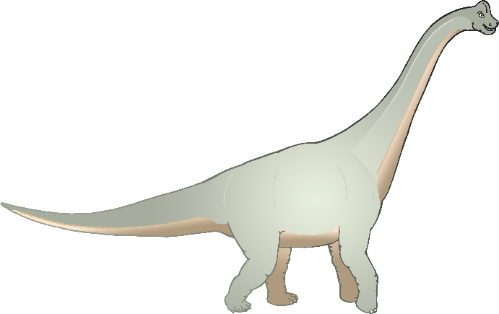

© 2022 Little Owls Resources

© 2022 Little Owls Resources

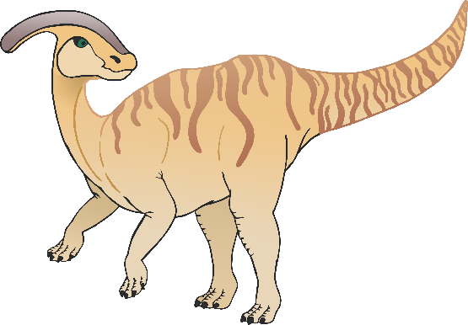

3

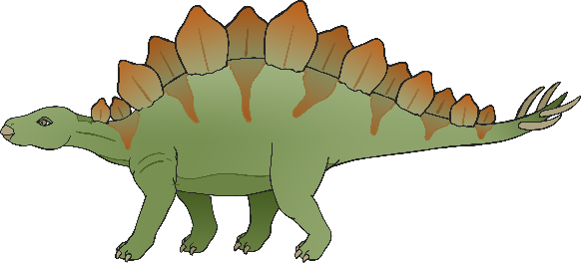

© 2022 Little Owls Resources

© 2022 Little Owls Resources

4

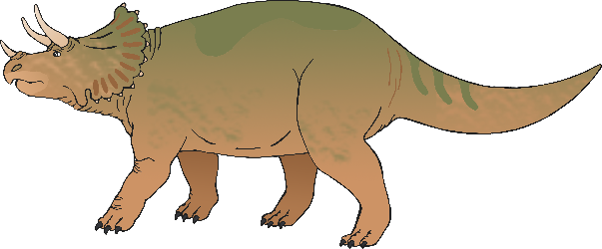

5

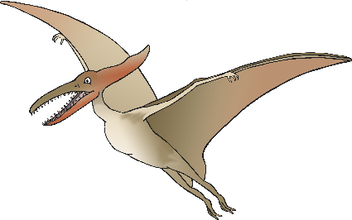

© 2022 Little Owls Resources

© 2022 Little Owls Resources

6

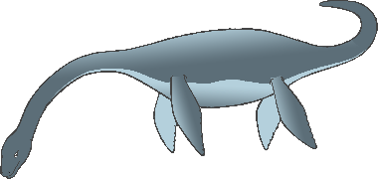

7

8

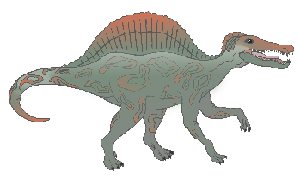

© 2022 Little Owls Resources

© 2022 Little Owls Resources

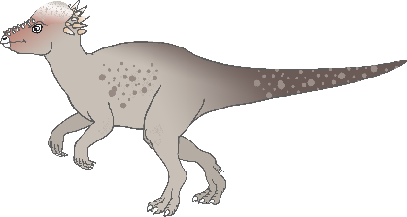

9

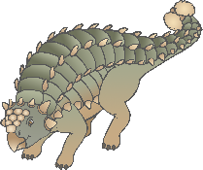

© 2022 Little Owls Resources

© 2022 Little Owls Resources

10