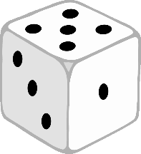

Make shadows! What shapes can you see?

Exploring Shape

© 2022 Little Owls Resources

Activity Inspiration Cards

© 2022 Little Owls Resources

Print shapes using paint!

Activity Inspiration Cards

Exploring Shape

© 2022 Little Owls Resources

Make impressions in sand!

Activity Inspiration Cards

Exploring Shape

© 2022 Little Owls Resources

Activity Inspiration Cards

Exploring Shape

Make impressions in playdough!

© 2022 Little Owls Resources

During junk modelling, explore and use different shaped cardboard boxes, tubes, bottles, etc.

Activity Inspiration Cards

Exploring Shape

© 2022 Little Owls Resources

Activity Inspiration Cards

Exploring Shape

Go on a 2D shape walk!

(Find real life objects that are shaped like 2D shapes)

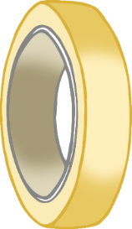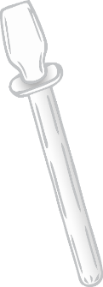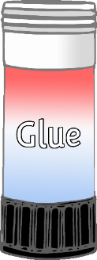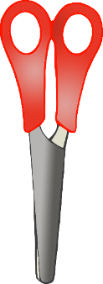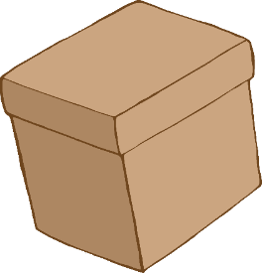

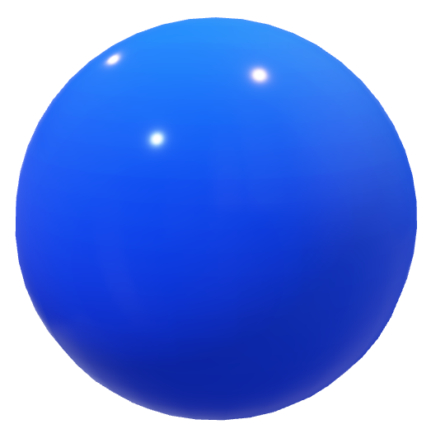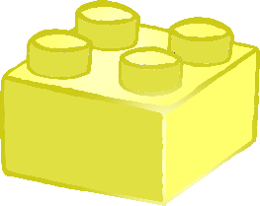

© 2022 Little Owls Resources

Go on a 3D shape walk!

(Find real life objects that are shaped like 3D shapes)

Activity Inspiration Cards

Exploring Shape

© 2022 Little Owls Resources

Activity Inspiration Cards

Exploring Shape

Go on a shape scavenger hunt!

© 2022 Little Owls Resources

Play with inset puzzles and jigsaws.

Activity Inspiration Cards

Exploring Shape

© 2022 Little Owls Resources

Activity Inspiration Cards

Exploring Shape

Free play with construction materials!

(e.g. building blocks, bricks, magnetic tiles)

© 2022 Little Owls Resources

Sort the shapes at tidy up time!

Activity Inspiration Cards

Exploring Shape

© 2022 Little Owls Resources

Activity Inspiration Cards

Exploring Shape

Copy patterns & pictures using 3D resources!

(e.g. building blocks, tangrams, found materials)

Rectangle

Square

© 2022 Little Owls Resources

What 2D shapes can you find on 3D shapes?

Activity Inspiration Cards

Exploring Shape

© 2022 Little Owls Resources

Activity Inspiration Cards

Exploring Shape

Can you put two 2D shapes together to make a new 2D shape?

+

=



© 2022 Little Owls Resources

Cut or fold paper to make shapes!

Activity Inspiration Cards

Exploring Shape

© 2022 Little Owls Resources

Activity Inspiration Cards

Exploring Shape

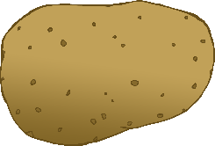

Free play with a wide range of objects e.g. vegetables, wooden pegs, spoons, corks, cones, balls, pots & pans, boxes, shape sorters and stacking cups!

© 2022 Little Owls Resources

Activity Inspiration Cards

Exploring Shape

© 2022 Little Owls Resources

Activity Inspiration Cards

Exploring Shape