Let’s Connect…

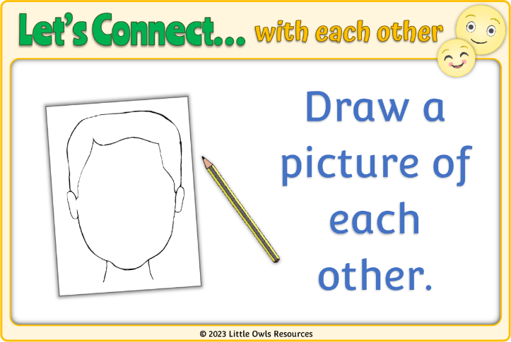

These prompt cards are ideas for fun activities that could be undertaken 1:1 with a child in the hopes of fostering a connection that could lead to talk.

A relaxed, fun situation is conducive to conversation which, as well as developing talking skills, will provide an opportunity for the child to express their feelings about themselves and others.

We hope this helps!

with each other

Play Connect Talk

© 2023 Little Owls Resources

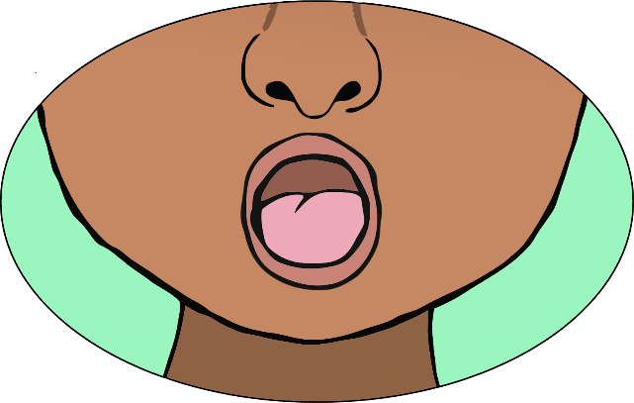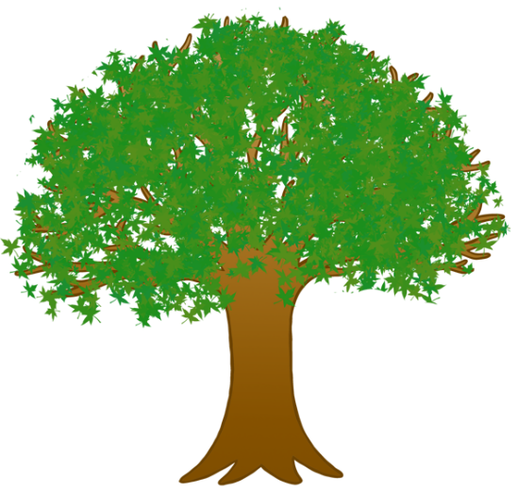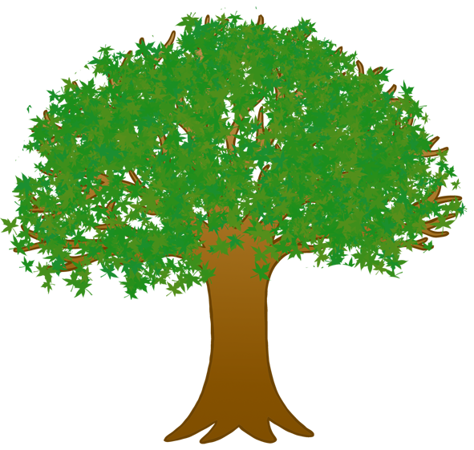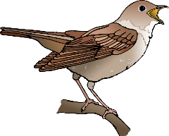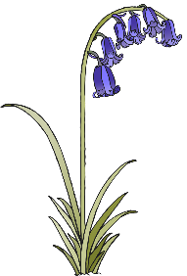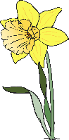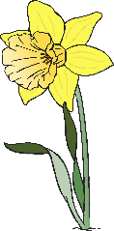

© 2023 Little Owls Resources

Go on a wildlife walk.

Let’s Connect…

with each other

© 2023 Little Owls Resources

Sing a song.

Let’s Connect…

with each other



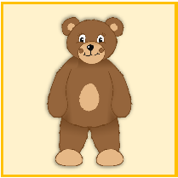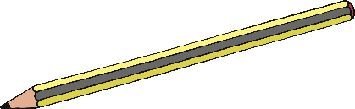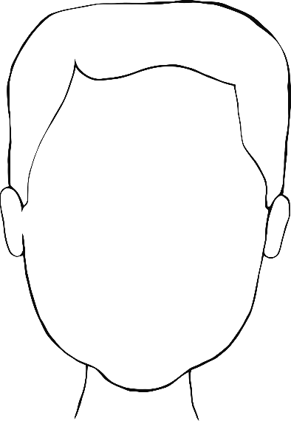

© 2023 Little Owls Resources

Draw a picture of each other.

Let’s Connect…

with each other



© 2023 Little Owls Resources

Play a memory game.

Let’s Connect…

with each other



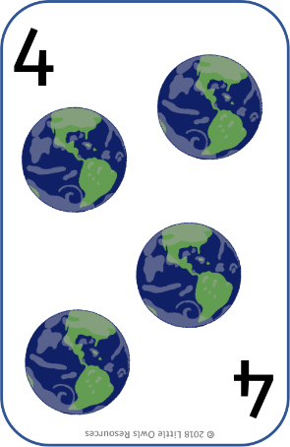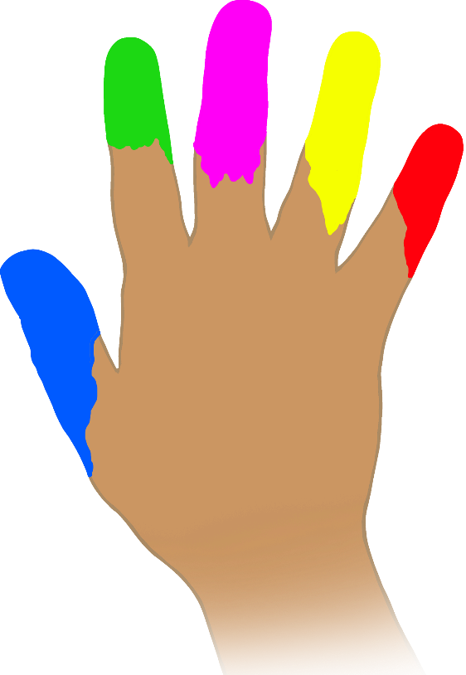

© 2023 Little Owls Resources

Messy play!

Let’s Connect…

with each other



© 2023 Little Owls Resources

Play a snap card game.

Let’s Connect…

with each other



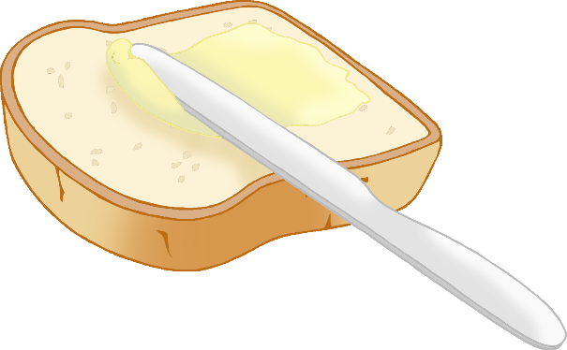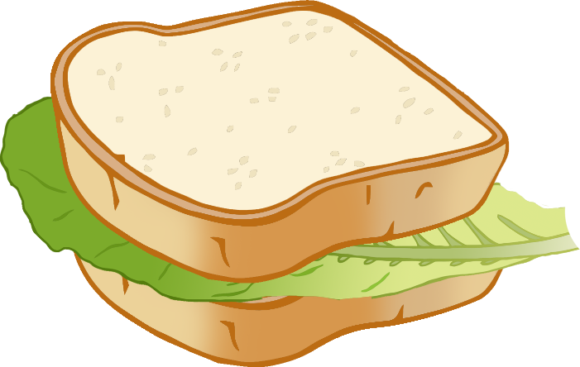

© 2023 Little Owls Resources

Create and wear some masks.

Let’s Connect…

with each other



© 2023 Little Owls Resources

Make a healthy sandwich.

Let’s Connect…

with each other





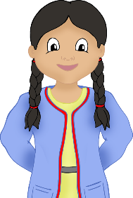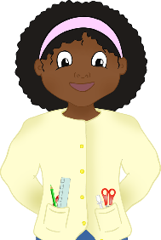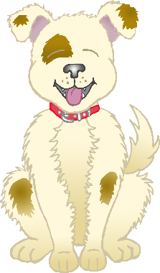

© 2023 Little Owls Resources

Share a book together.

Let’s Connect…

with each other



© 2023 Little Owls Resources

Look at some photos together.

Let’s Connect…

with each other



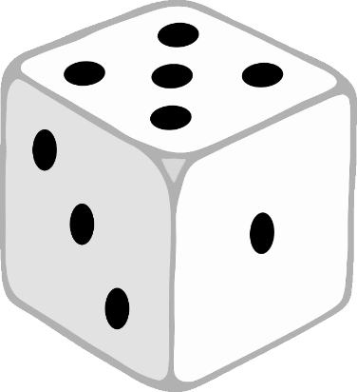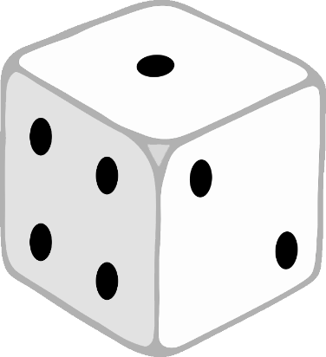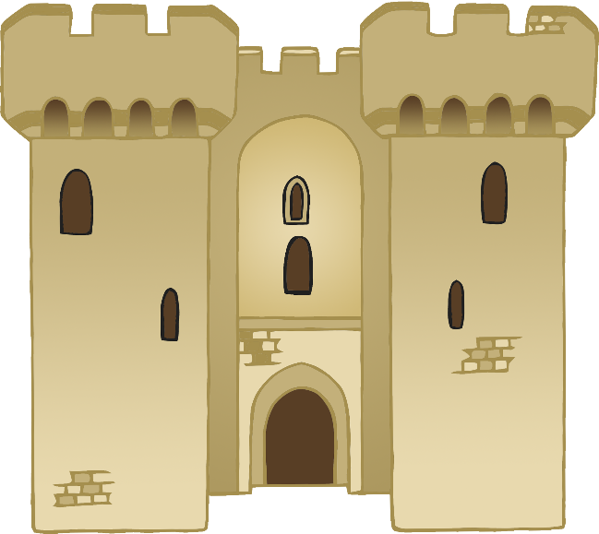

© 2023 Little Owls Resources

Play a board game.

Let’s Connect…

with each other



© 2023 Little Owls Resources

Build a fort!

Let’s Connect…

with each other



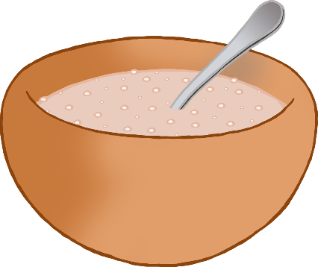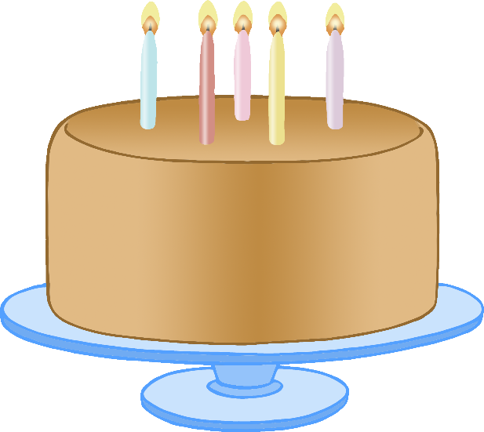

© 2023 Little Owls Resources

Play a ball game.

Let’s Connect…

with each other



© 2023 Little Owls Resources

Make and bake a cake.

Let’s Connect…

with each other



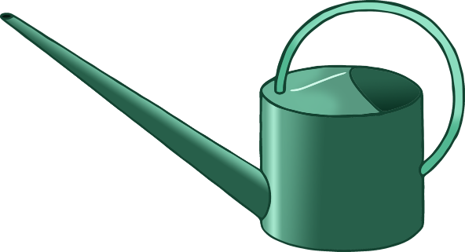

© 2023 Little Owls Resources

Planting or caring for plants.

Let’s Connect…

with each other



© 2023 Little Owls Resources

Paint a picture.

Let’s Connect…

with each other



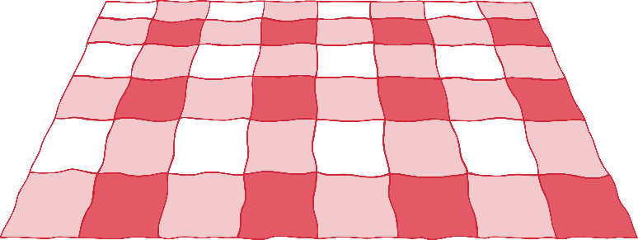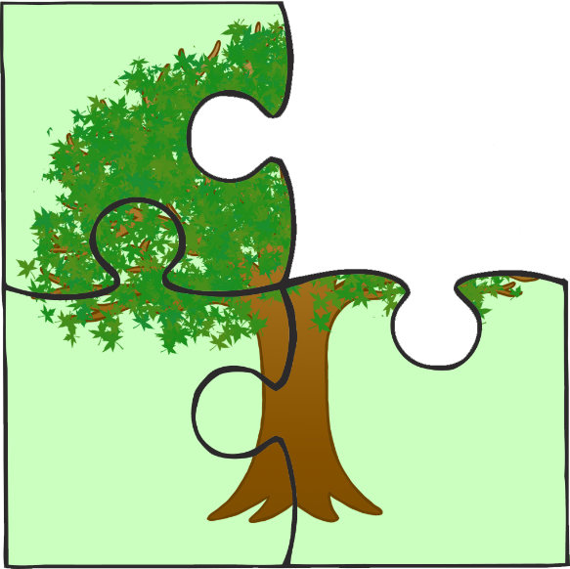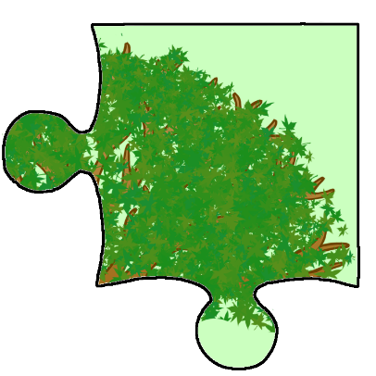

© 2023 Little Owls Resources

Solve a jigsaw puzzle.

Let’s Connect…

with each other



© 2023 Little Owls Resources

Playdough picnic!

Let’s Connect…

with each other



© 2023 Little Owls Resources

Treasure hunt.

Let’s Connect…

with each other



© 2023 Little Owls Resources

Dance, dance, dance!

Let’s Connect…

with each other



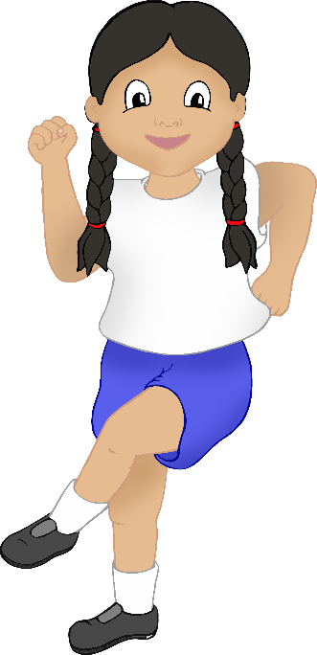

© 2023 Little Owls Resources

Let’s Connect…

with each other



© 2023 Little Owls Resources

Let’s Connect…

with each other

