Let’s Connect…

On this poster are ideas for fun activities that could be undertaken 1:1 with a child in the hopes of fostering a connection that could lead to talk.

A relaxed, fun situation is conducive to conversation which, as well as developing talking skills, will provide an opportunity for the child to express their feelings about themselves and others.

We hope this helps!

© 2023 Little Owls Resources

Play Connect Talk

with each other

© 2023 Little Owls Resources

Go on a wildlife walk.

Let’s Connect…

with each other

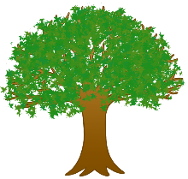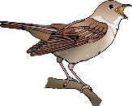

Sing a song.

Draw a picture of each other.

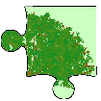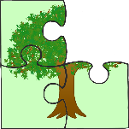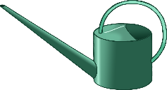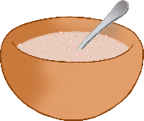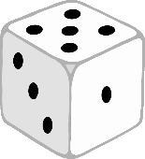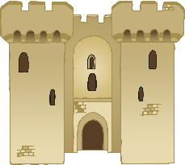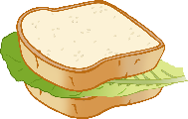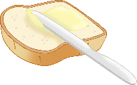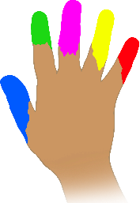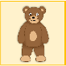

Dance, dance.

Planting or caring for plants.

Play a ball game.

Play a board game.

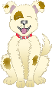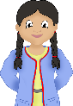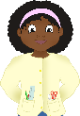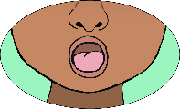

Treasure hunt.

Playdough picnic.

Solve a jigsaw puzzle.

Paint a picture.

Make and bake a cake.

Build a fort!

Look at some photos together.

Share a book together.

Make a healthy sandwich.

Create and wear some masks.

Play a snap card game.

Messy play!

Play a memory game.

© 2023 Little Owls Resources

Let’s Connect…

with each other

