Let’s get…

moving

These prompt cards are ideas for movement activities.

As well as being good for the body, movement and exercise are also an important part of a healthy mind!

We hope this helps!

© 2023 Little Owls Resources

© 2023 Little Owls Resources

Play a game at the park!

Let’s get…



Try some yoga!

moving

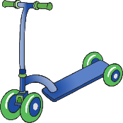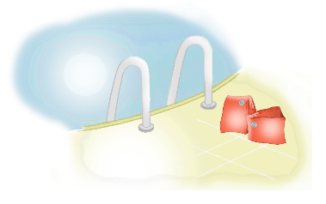

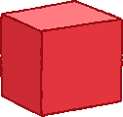

Bounce a ball!

Run a race!

Help with chores!

Play on playground equipment!

Act out nursery rhymes!

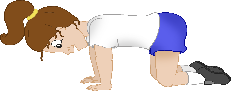

Play hide and seek!

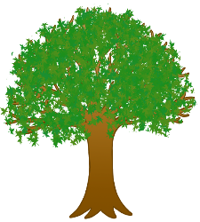

Treasure hunt!

Go for a swim!

Make an obstacle course!

Look for minibeasts!

Go for a walk!

Dance to some music!

Hula hooping!

Go on a maths hunt!

Play on ride-ons!

Build a den!

Role-play!

Do some gardening!

© 2023 Little Owls Resources

Let’s get…

moving

