**Let’s show…**

kindness

This poster contains ideas for showing kindness.

These ideas will hopefully spark more of your own and those of the children too!

We hope this helps!

© 2023 Little Owls Resources

© 2023 Little Owls Resources

Hug someone you care about.

**Let’s show…**



Have a nice chat with someone.

kindness

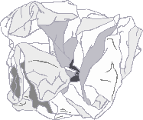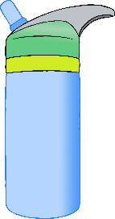

Be helpful to the adults that help you!

Write a letter or draw a picture for your grandparents.

Draw a picture for a friend.

Tell someone you love that you love them!

Take a walk with a friend.

Say please.

Please.

Thank-you.

Pick up rubbish.

Drink some water and encourage a friend to as well.

Say well done to yourself!

**Well done me!**

Are you okay?

Ask someone how they are doing.

Thank-you!

Send a thank-you note.

Let someone ahead of you in a line.

Smile.

Open a door for someone.

Pay someone a compliment.

I love your haircut!

Say thank-you.

Share your favourite book with a friend.

Be a friend to someone who is sad.

© 2023 Little Owls Resources

**Let’s show…**



kindness