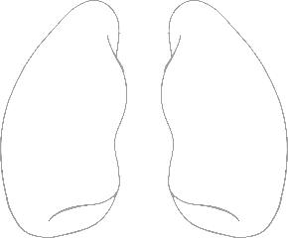

Colour, cut & stick - lungs

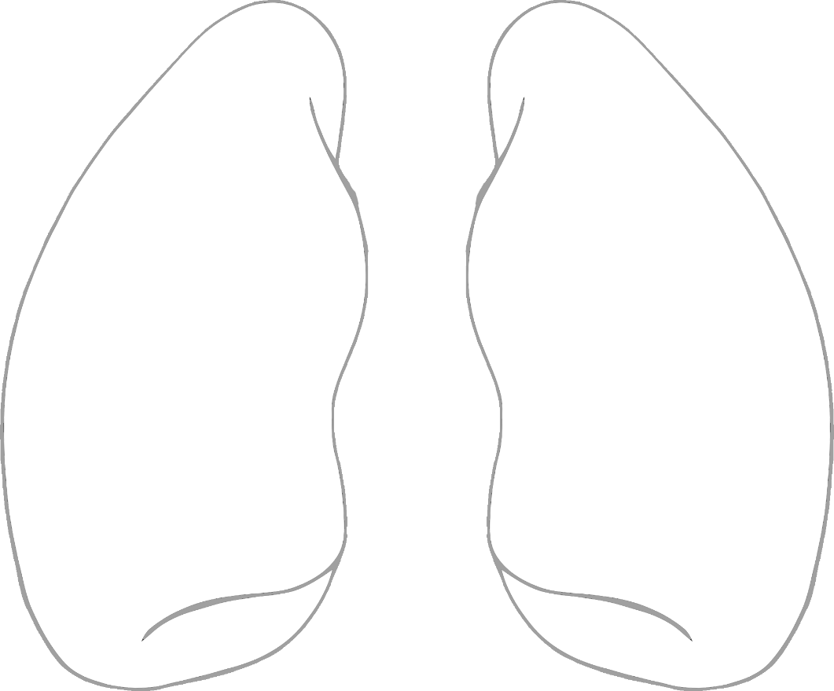

© 2023 Little Owls Resources

© 2023 Little Owls Resources