Mindfulness Walks

This poster contains ideas for walks that promote mindfulness and encourage an awareness of surroundings.

The ideas are intended to give the children time and space to focus on one thing at a time, remaining in the present moment.

© 2023 Little Owls Resources



Mindfulness Walks

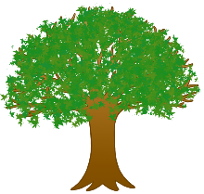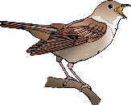



Natural art

Breathe in…

Breathe out…

Rubbings

*(Find colours in rainbow order.)*

Sketches

*(Draw a certain number of sketches on your walk.)*



*(Find 5 interesting stones on your walk.)*

*(Find 5 interesting sticks on your walk.)*

Sounds

Smells

Sights

Magnifier

Rainbow

Sticks

Stones

Deep breaths

Textures

Noticing wildlife

Body shape poses

Collecting

Colours

© 2023 Little Owls Resources