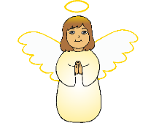

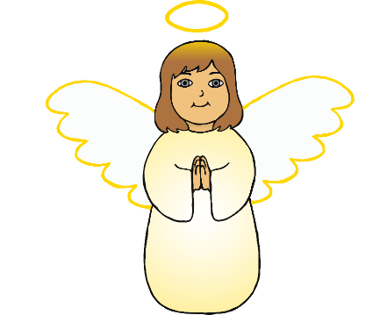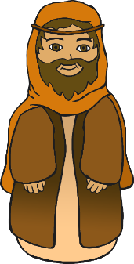

© 2019 Little Owls Resources

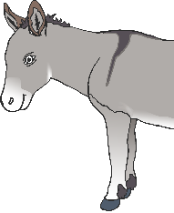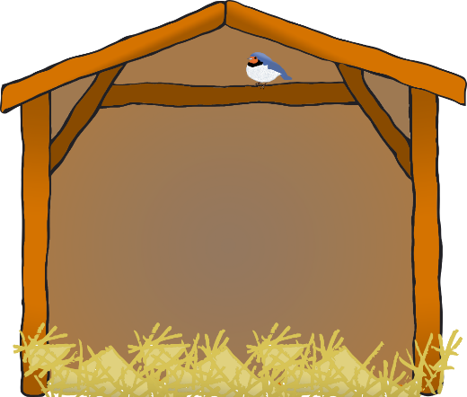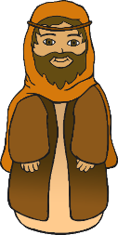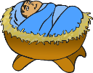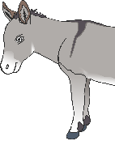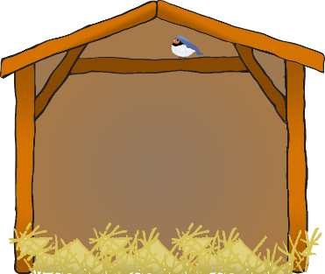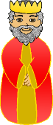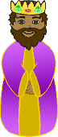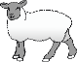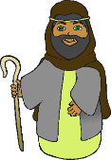

© 2019 Little Owls Resources

© 2019 Little Owls Resources

© 2019 Little Owls Resources

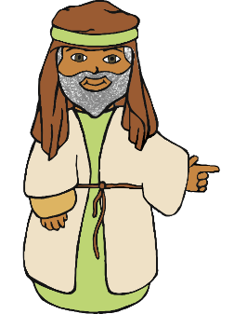

© 2019 Little Owls Resources

© 2019 Little Owls Resources

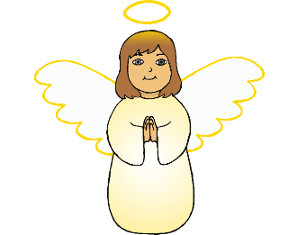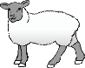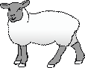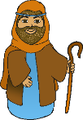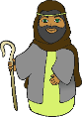

© 2019 Little Owls Resources

An angel told Mary and Joseph that they were going to have a special baby.

© 2019 Little Owls Resources

© 2019 Little Owls Resources

© 2019 Little Owls Resources

© 2019 Little Owls Resources

Mary and Joseph travelled to Bethlehem.

Mary rode on a donkey.

Jesus was born to Mary in the stable.

A new star appeared in the sky.

Everyone was so happy that Jesus had arrived.

© 2019 Little Owls Resources

© 2019 Little Owls Resources

© 2019 Little Owls Resources

An angel appeared to the shepherds to tell them that Jesus had been born.

All the inns were full. An innkeeper said that they could stay in his stable.

Three kings travelled a long way to meet Jesus. They followed the new star.