Outdoor Area

Birth to 3

Maths Activity Cards

These activity cards provide ideas to encourage and facilitate mathematical development in the outdoor area. They can be used as a planning tool as well as at the moment of the activity.

This pack is aimed at the Birth to 3 age group. The descriptions are intended for the adult to read, with the bright colourful images there to provide visual reminders for the child where appropriate.

© 2022 Little Owls Resources

© 2022 Little Owls Resources

Birth to 3

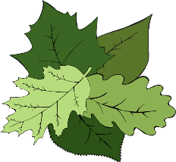

Outdoor Area

Maths Activity Cards

Sing finger rhymes with numbers such as…

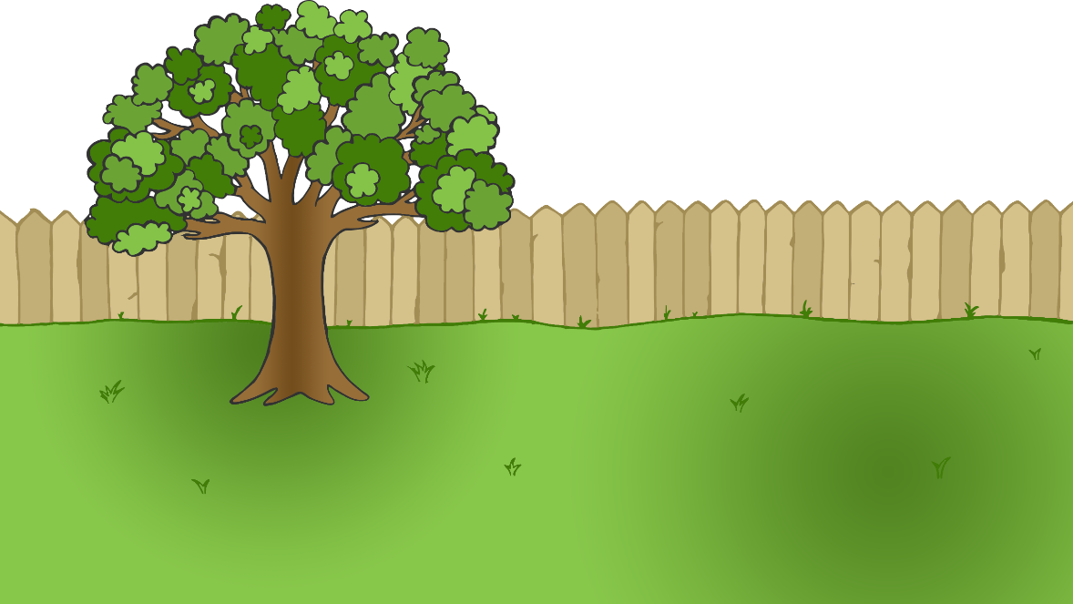

Round and round the garden,

like a teddy bear,

one step, two step,

tickle you under there!

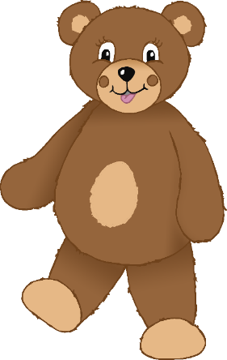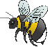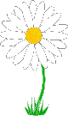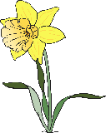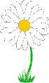

© 2022 Little Owls Resources

Birth to 3



Outdoor Area

Maths Activity Cards

Sing finger rhymes which demonstrate changes in a group of up to three items such as…

Two little dicky birds sitting on a wall

One named Peter, one named Paul

Fly away, Peter, fly away, Paul

Come back, Peter, come back, Paul

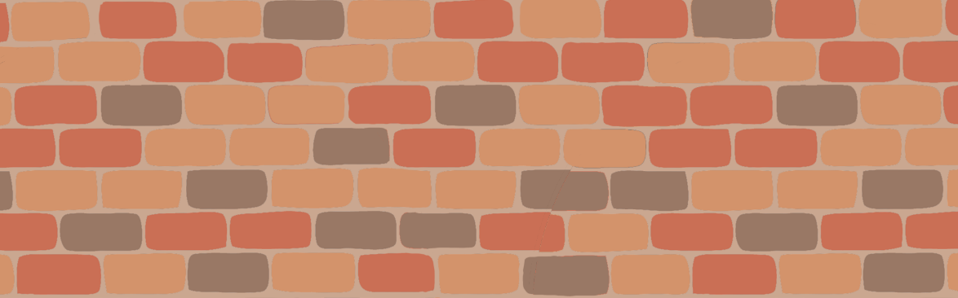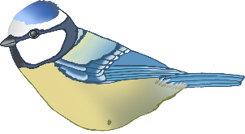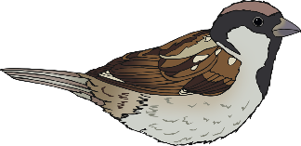

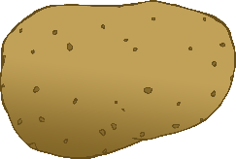

© 2022 Little Owls Resources

Birth to 3

Outdoor Area

Maths Activity Cards

Make available objects to put in and out of others, for example a cooking theme…

© 2022 Little Owls Resources

Birth to 3

Outdoor Area

Maths Activity Cards

Encourage babies and young toddlers to play with cups…

* Encourage babies and young toddlers to play freely with objects.
* When appropriate, sensitively join in and comment.
* Nesting theme (putting one inside another and out again).
* Hiding one “Where has it gone?”
* Stacking them in a tower.
* Lining them up.

Offer repeated experiences with the counting sequence in meaningful and varied context, e.g. counting objects outdoors…

Encourage the development of counting-like behaviour, e.g. putting on a coat…

* When putting a child’s coat on to go into outdoor area cheerfully say “1” and then “2” as each arm goes through.
* Count the buttons as they are fastened in a sing song like voice.

© 2022 Little Owls Resources

Birth to 3

Outdoor Area

Maths Activity Cards

© 2022 Little Owls Resources

Birth to 3

Outdoor Area

Maths Activity Cards

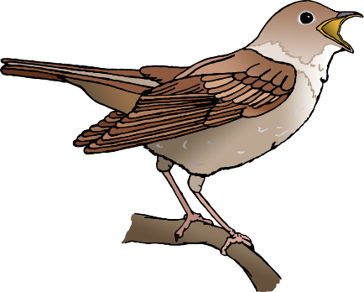

Cars going past

Dog barks

Bird tweets

Steps

Jumps

Claps

Offer repeated experiences with the counting sequence in meaningful and varied context, e.g. counting sounds…

Offer repeated experiences with the counting sequence in meaningful and varied context, e.g. counting actions…

© 2022 Little Owls Resources

Birth to 3

Outdoor Area

Maths Activity Cards

© 2022 Little Owls Resources

Birth to 3

Outdoor Area

Maths Activity Cards

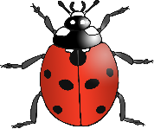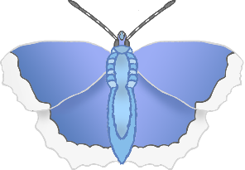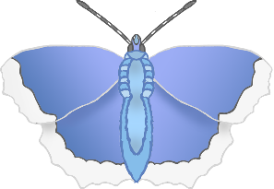

3

4

2

1

* Move an object to one side once they have counted it.
* (If children are saying one number word for each object, it is not always necessary to correct them if they skip a number. Learning to count accurately takes a long time and repeated experience. Confidence is important.)

Help children to match their counting words with objects e.g. count objects which can be moved in the outdoor area such as stones, sticks, small world characters, bricks…

Compare amounts and draw attention to change in amounts in your outdoor area using words such as ‘lots’, ‘more’ or ‘same’…

© 2022 Little Owls Resources

Birth to 3

Outdoor Area

Maths Activity Cards

© 2022 Little Owls Resources

Birth to 3

Outdoor Area

Maths Activity Cards

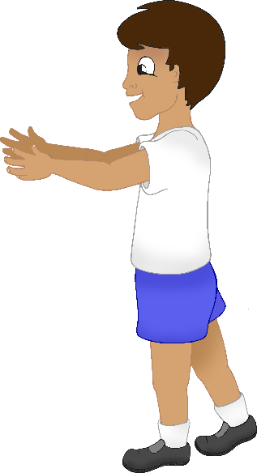

* Use spatial words like ‘on top of’, ‘up’, ‘down’ and ‘through’.

© 2022 Little Owls Resources

Birth to 3

Outdoor Area

Maths Activity Cards

Provide opportunities for children to climb, tunnel and hide…

© 2022 Little Owls Resources

Birth to 3

Outdoor Area

Maths Activity Cards

Build with a range of resources, e.g. provide blocks or boxes for children to play freely with…

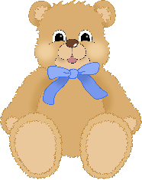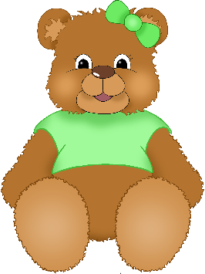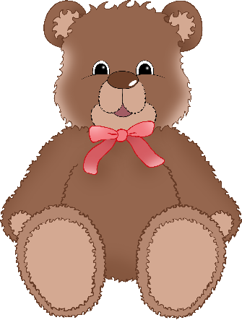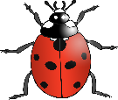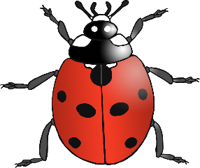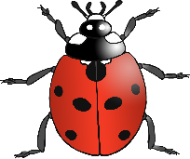

* Why not place the objects in order? e.g. dolls in height order, sticks in length order.

Compare heights and lengths of objects in the outdoor area using language such as tall/taller/long/longer/short/shorter and high/low.…

* Why not place the small objects such as stones, teddies, cups, and bowls in one pile and big objects in another?

© 2022 Little Owls Resources

Birth to 3

Outdoor Area

Maths Activity Cards

Compare sizes of objects in the outdoor area using language such as big/bigger/little/small/smaller…

© 2022 Little Owls Resources

Birth to 3

Outdoor Area

Maths Activity Cards

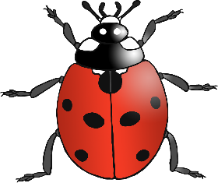

* Use words such as ‘repeated’ and ‘the same’.
* Look closely at patterns on leaves, flowers, snail shells, spider webs, raindrops, rings on a tree stump, pinecones, pavement or brick work, tiles, wooden planks on outdoor furniture, insides of fruit and vegetables, shells.
* Use words such as ‘repeated’ and ‘the same’.

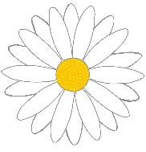

© 2022 Little Owls Resources

Birth to 3

Outdoor Area

Maths Activity Cards

Provide opportunities for children to notice patterns in the outdoor area…

© 2022 Little Owls Resources

Birth to 3

Outdoor Area

Maths Activity Cards

Provide opportunities for children to arrange natural objects in the outdoor area into repeating patterns…