trees

flowers

leaves

© 2022 Little Owls Resources

© 2022 Little Owls Resources

© 2022 Little Owls Resources

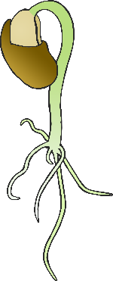



grass

water

grow

© 2022 Little Owls Resources

© 2022 Little Owls Resources

© 2022 Little Owls Resources

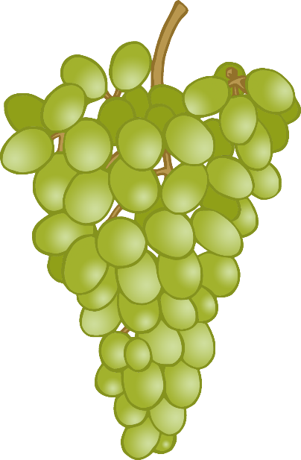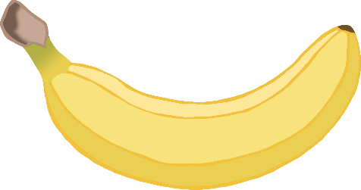

vegetables

fruit

sunlight

© 2022 Little Owls Resources

© 2022 Little Owls Resources

© 2022 Little Owls Resources

soil

nuts

seeds

© 2022 Little Owls Resources

© 2022 Little Owls Resources

© 2022 Little Owls Resources

paper

card

wood

© 2022 Little Owls Resources

© 2022 Little Owls Resources

© 2022 Little Owls Resources

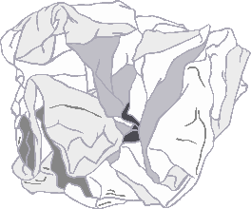

branch

stem

petal

© 2022 Little Owls Resources

© 2022 Little Owls Resources

© 2022 Little Owls Resources

roots

trunk

twig

© 2022 Little Owls Resources

© 2022 Little Owls Resources

© 2022 Little Owls Resources