Queen Elizabeth II

© 2022 Little Owls Resources

c

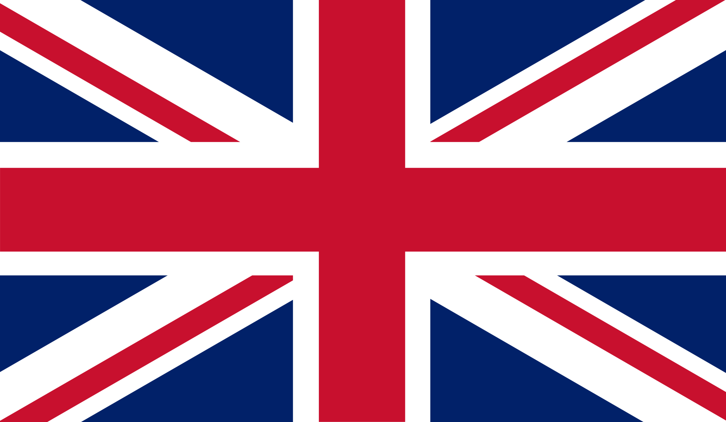

**1926 - 2022**

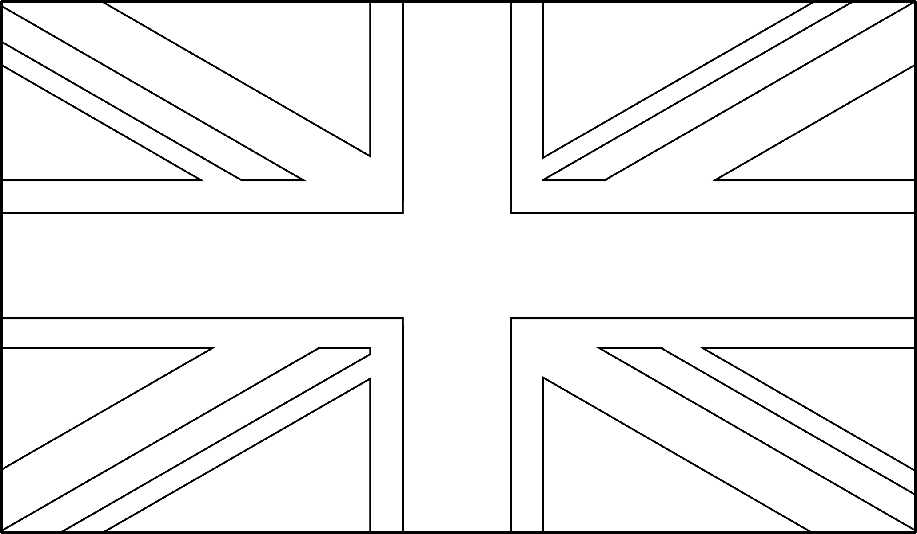

Queen Elizabeth II

© 2022 Little Owls Resources

c

**1926 - 2022**