© 2020 Little Owls Resources

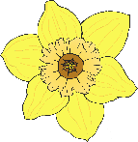

**Spring Walk Checklist ✔️✔️✔️**

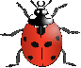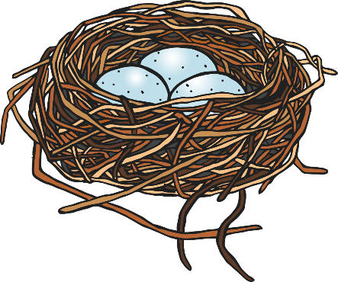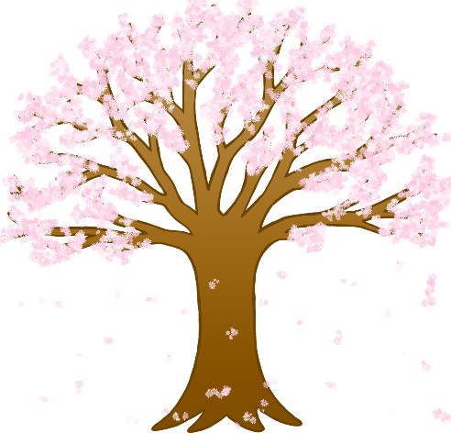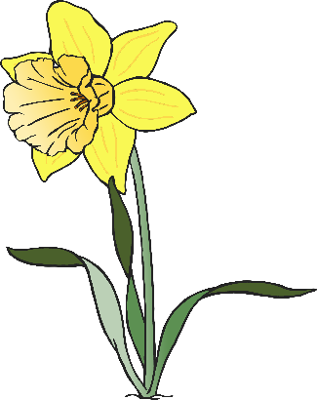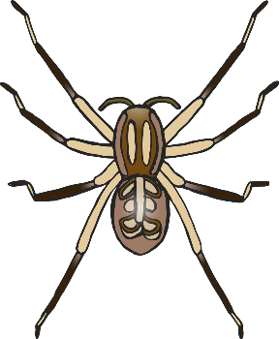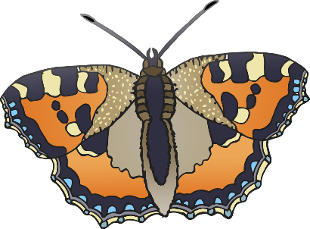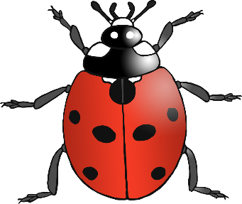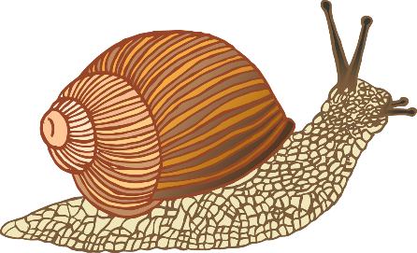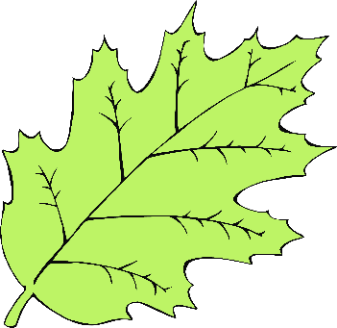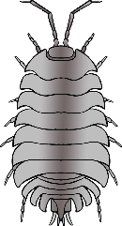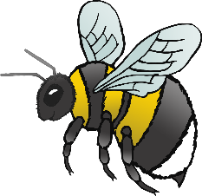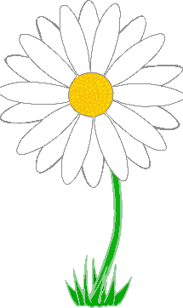

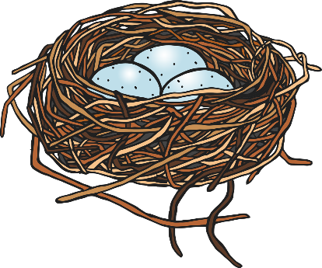

bee

daisy

bird’s nest

butterfly

spider

© 2020 Little Owls Resources

**Spring Walk Checklist ✔️✔️✔️**

woodlouse

blossom

daffodil

green leaf

ladybird

snail