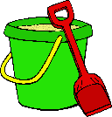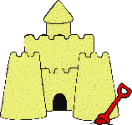

Summer ideas

writing prompts

These writing prompts will help encourage mark-making and writing along a summer theme.

The sheets cover an ability range from first mark-making up to full sentence writing.

The first sheet is intended to allow open ended recording of summer ideas by the child. An open space for marks, drawing and labelling as they recall their experiences.

Later sheets encourage writing using blending and offer some scaffolding towards greater difficulty and independence.

**We hope these sheets are useful to you!**

© 2020 Little Owls Resources

What can you see in the summer?



© 2020 Little Owls Resources

I see a _____

I see a _____

What can you see in the summer?



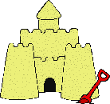

© 2020 Little Owls Resources

I see a _____

_____________

What can you see in the summer?





© 2020 Little Owls Resources



__________________________

What can you see in the summer?



© 2020 Little Owls Resources

What can you see in the summer?





© 2020 Little Owls Resources

I see a _____

I see a _____

I see a _____

I see _ _____

I ___ _ _____

I ___ _ _____



© 2020 Little Owls Resources

I see a _____

I see _ _____

I ___ _ _____

_ ___ _ _____

_ ___ _ _____

_ ___ _ _____

What can you see in the summer?



© 2020 Little Owls Resources

______________________________________________________________________________

What can you see in the summer?