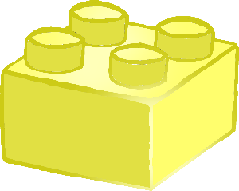

Characteristics of effective teaching and learning

**“Children investigate and experience things, and ‘have a go’.”**

**Playing** and Exploring

© 2021 Little Owls Resources *Contains public sector information licensed under the Open Government Licence v3.0.*

**“Children concentrate and keep on trying if they encounter difficulties and enjoy achievements.”**

Active Learning

Characteristics of effective teaching and learning

© 2021 Little Owls Resources *Contains public sector information licensed under the Open Government Licence v3.0.*

© 2021 Little Owls Resources *Contains public sector information licensed under the Open Government Licence v3.0.*

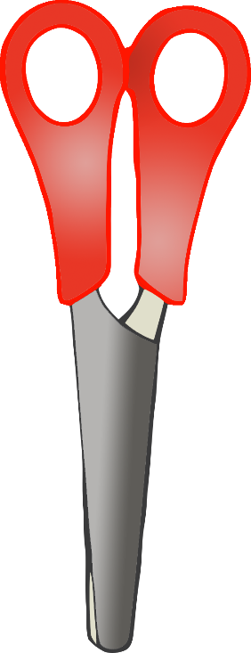

Thinking Critically

and

**Creating**

“Children have and develop their own ideas, make links between ideas, and develop strategies for doing things.”

Characteristics of effective teaching and learning