Characteristics of effective teaching and learning

© 2021 Little Owls Resources *Contains public sector information licensed under the Open Government Licence v3.0.*

Children will be learning to:

Realise that their actions have an effect on the world, so they want to keep repeating them.

Guide their own thinking and actions by referring to visual aids or by talking to themselves while playing. For example, a child doing a jigsaw might whisper under their breath: “Where does that one go? – I need to find the big horse next.”

Plan and think ahead about how they will explore or play with objects.

Make independent choices.

Respond to new experiences that you bring to their attention.

Bring their own interests and fascinations into early years settings. This helps them to develop their learning.

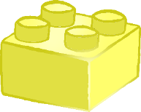

**Playing** and Exploring

Keep on trying when things are difficult.

Begin to correct their mistakes themselves. For example, instead of using increasing force to push a puzzle piece into the slot, they try another piece to see if it will fit.

Participate in routines, such as going to their cot or mat when they want to sleep.

Begin to predict sequences because they know routines. For example, they may anticipate lunch when they see the table being set, or get their coat when the door to the outdoor area opens.

Show goal-directed behaviour. For example, babies may pull themselves up by using the edges of a low table to reach for a toy on top of the table. Toddlers might turn a storage box upside down so they can stand on it and reach up for an object.

Characteristics of effective teaching and learning

© 2021 Little Owls Resources *Contains public sector information licensed under the Open Government Licence v3.0.*

Children will be learning to:

Active Learning

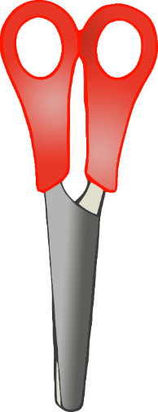

Concentrate on achieving something that’s important to them. They are increasingly able to control their attention and ignore distractions.

Know more, so feel confident about coming up with their own ideas.

Make more links between those ideas.

Use pretend play to think beyond the ‘here and now’ and to understand another perspective. For example, a child role-playing the billy goats gruff might suggest that “Maybe the troll is lonely and hungry? That’s why he is fierce.”

Review their progress as they try to achieve a goal. Check how well they are doing.

Solve real problems: for example, to share nine strawberries between three friends, they might put one in front of each, then a second, and finally a third. Finally, they might check at the end that everyone has the same number of strawberries.

Take part in simple pretend play. For example, they might use an object like a brush to pretend to brush their hair, or ‘drink’ from a pretend cup.

Sort materials. For example, at tidy-up time, children know how to put different construction materials in separate baskets.

Characteristics of effective teaching and learning

© 2021 Little Owls Resources *Contains public sector information licensed under the Open Government Licence v3.0.*

Children will be learning to:

**Creating**

and

Thinking Critically