Numeracy

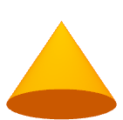

3

2

1

Wall

6

© 2023 Little Owls Resources

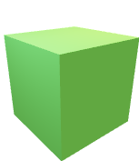

2

9

4

8

3

© 2023 Little Owls Resources

S T E

Engineering

Technology

Science

A M

© 2023 Little Owls Resources

2

3

1

Art

Mathematics

Challenge Wall

Try something new!

Challenge yourself!

I can do it!

© 2023 Little Owls Resources

Book

© 2023 Little Owls Resources

Wall

© 2023 Little Owls Resources

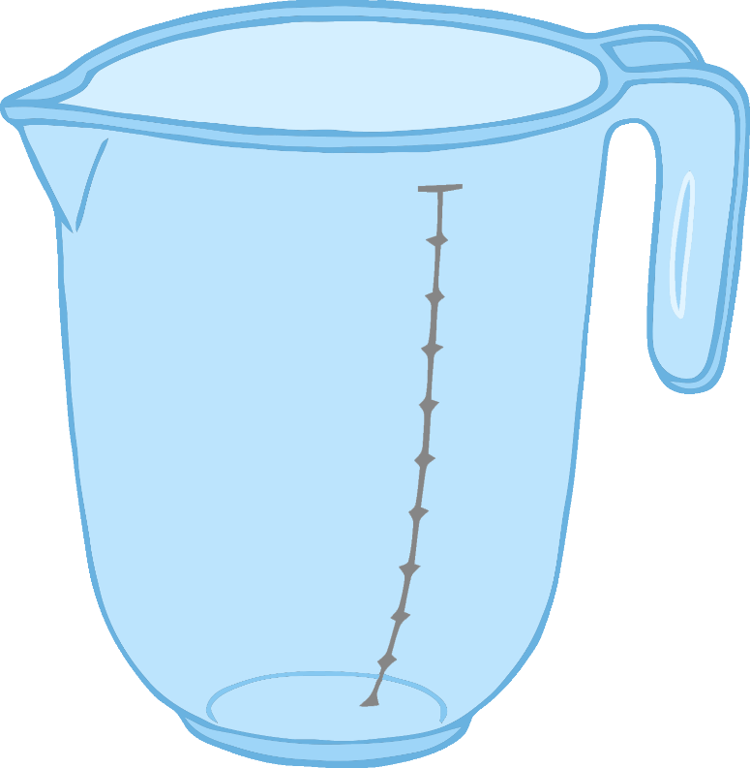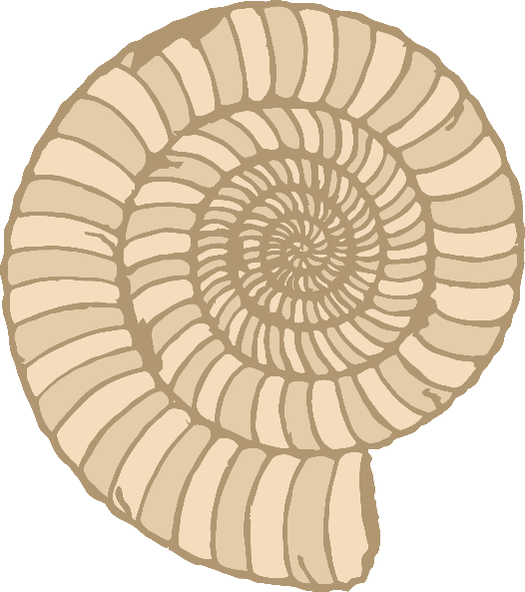

Exploration

Wall

© 2023 Little Owls Resources

Cooking Wall

© 2023 Little Owls Resources

Number

**1**

**2**

**3**

Area

**7**

**3**

© 2023 Little Owls Resources

**3**

**2**

**8**

**4**