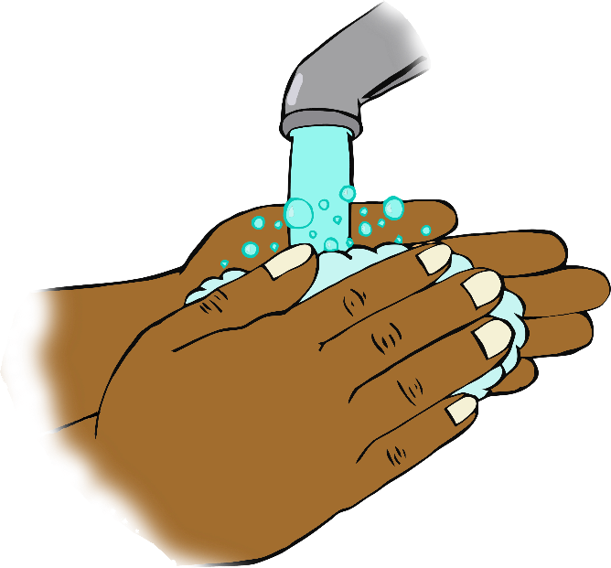

Sing twice through as you wash your hands!

Hey diddle diddle,

the cat and the fiddle,

the cow jumped over the moon.

The little dog laughed,

to see such fun,

and the dish ran away with the spoon.

**Hey Diddle Diddle**