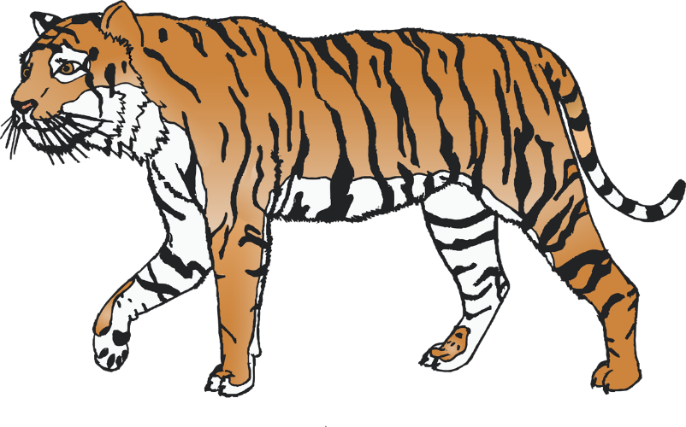

**Zoo Animals**

**Lollipop Puppets**

